[Books](https://www.newyorker.com/magazine/books)

Why Storytelling Is Part of Being a Good Doctor

*Physicians’ education puts science front and center, but narrative can be a surprisingly powerful medicine.*

**By**[**Jerome Groopman**](https://www.newyorker.com/contributors/jerome-groopman)

July 18, 2022

*THE NEW YORKER MAGAZINE*

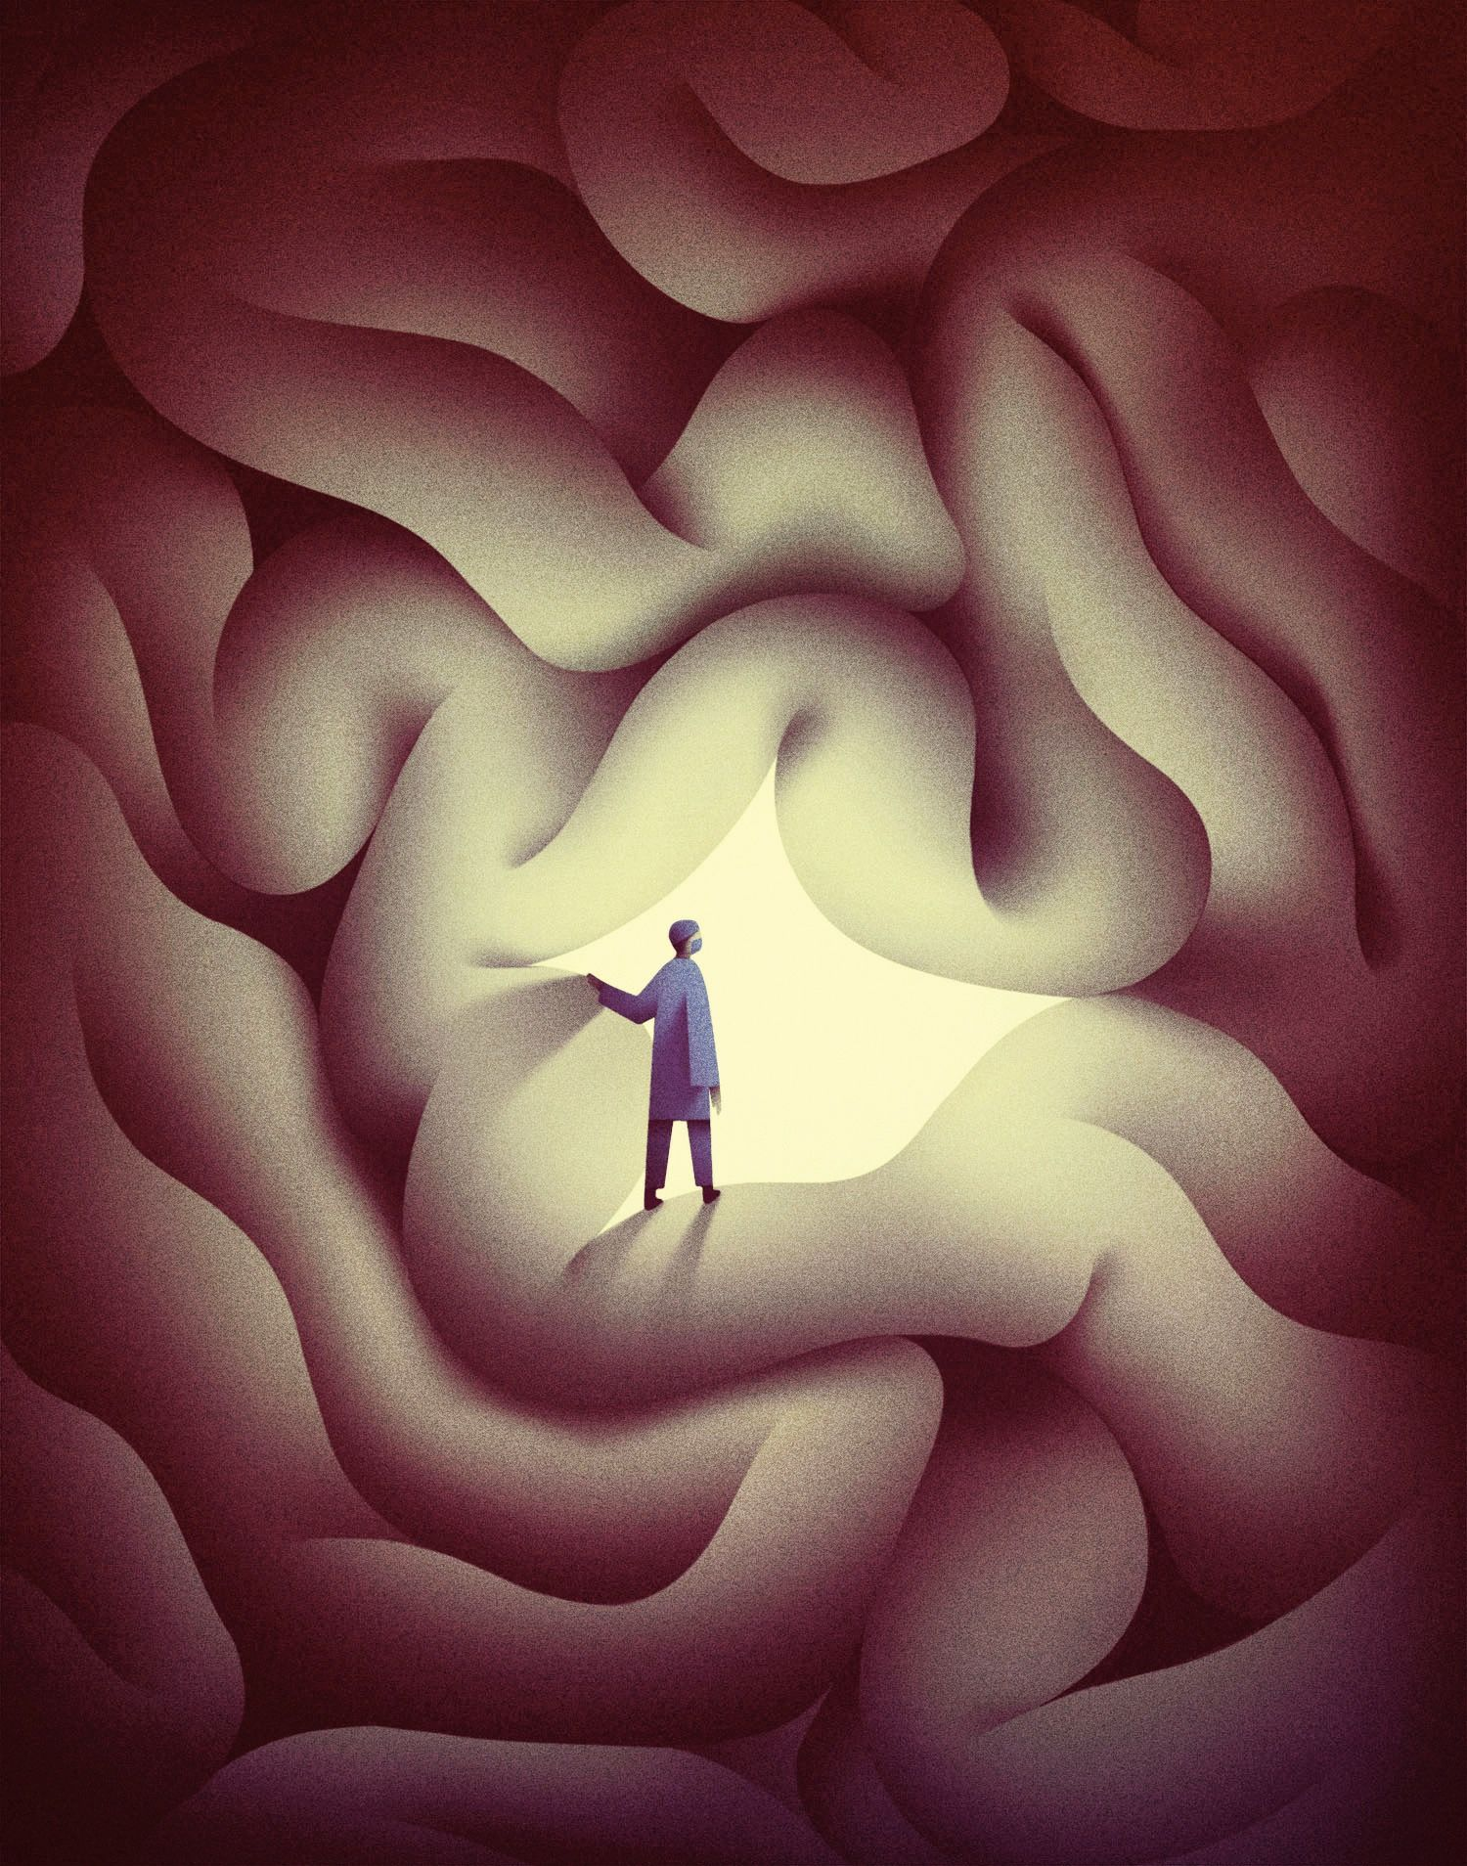

A new memoir takes the reader into the world of pediatric neurosurgery.Illustration by Sophi Miyoko Gullbrants

Listen to This Page·15 min

Summarize

It wasn’t until my mid-forties that I began to write about the world of medicine. Before that, I was busy building a career as a hematologist-oncologist: caring for patients with blood diseases, cancer, and, later, AIDS; establishing a research laboratory; publishing papers; training junior physicians. A doctor’s workload tends to crowd out everything but the most immediate concerns. But, as the years pass, the things you’ve pushed to the back of your mind start to pile up, demanding to be addressed. For two decades, I had seen my patients and their loved ones face some of life’s most uncertain moments, and I now felt driven to bear witness to their stories.

After writing and revising three chapters of what I envisioned as my first book, I showed a draft to my wife, an endocrinologist. She read them, and then looked at me squarely. “They’re awful,” she said. I was taken aback. I’d felt pretty good about what I had produced. “They’re overwritten, with run-on sentences, filled with fancy words,” she explained. I stayed silent, absorbing her criticism. “I can’t really figure out what you’re trying to say here.”

I reread my words and concluded that she was right. What’s more, I realized that many of the problems with my draft reflected the conditioning that occurs during medical training. I had used technical jargon, as if communicating with colleagues, rather than addressing a general reader. And I had removed myself from the stories, a result of the psychological distancing needed to remain steady while helping a patient coping with a life-threatening disease. Finally, I’d focussed on the clinical details of the cases, instead of exploring patients’ emotional and spiritual dilemmas—the very thing that had moved me to write in the first place.

What I needed was a new kind of training, analogous to my medical training but very different. So I reread some of the physician writers whom I most admired: [Oliver Sacks](https://www.newyorker.com/contributors/oliver-sacks), Richard Selzer, Sherwin Nuland, William Carlos Williams, Anton Chekhov. I started to appreciate how they used their individual perspectives and styles to illuminate the experiences of those struggling with illness. They made their own reactions part of the story and, in doing so, immersed the reader in a fundamental struggle of the profession: balancing the ego required to take responsibility for another person’s life with the humility to acknowledge our capacity for catastrophic error.

Today, my library shelves are filled with books by doctors, spanning the whole arc of a medical career—from “[A Not Entirely Benign Procedure](https://www.amazon.com/Not-Entirely-Benign-Procedure-Medical/dp/0452272580),” a memoir of medical-student life by the N.Y.U. pediatrician Perri Klass, to the self-lacerating retrospect of the British surgeon Henry Marsh’s “[Do No Harm](https://www.amazon.com/Do-No-Harm-Stories-Surgery/dp/125006581X/ref=tmm_hrd_swatch_0?_encoding=UTF8&qid=1658167032&sr=1-1),” which broods on mistakes made during a long and outwardly illustrious career. Somewhere between these, I can now slot in Jay Wellons’s vivid mid-career memoir, “[All That Moves Us](https://www.amazon.com/All-That-Moves-Pediatric-Neurosurgeon/dp/0593243366/ref=tmm_hrd_swatch_0?_encoding=UTF8&qid=1658167053&sr=1-1)” (Random House). Wellons is the chief of pediatric neurosurgery at the Vanderbilt University Medical Center, in Nashville, and has begun to write, as I did, after some twenty years in medicine.

His book unfolds in a harrowing series of operating-room vignettes, explaining the work of his hands while also evoking the tension in his mind and his heart. Before his medical training, Wellons was an English major at the University of Mississippi, where he took writing classes with the novelist Barry Hannah and the poet Ellen Douglas. It shows, both in his narrative control and in the freshness of his descriptive touches. Here he is on the first glimpse of a brain—with its tissues and blood vessels and crevices—once the skull is opened:

You peer forward into the eyepieces, and your gaze is directed straight down onto the surface of the brain, to a scene the likes of which only few have encountered, initially as alien as the moonscape must have been to its early visitors. Except instead of desolate grayness all around, the brain’s surface is bursting with color and light, with dimension and depth. It takes a moment for your eyes to adjust to the sudden brightness.

Wellons’s journey into medicine was influenced by his father, who had wanted to be a doctor, but whose family couldn’t afford the training. Instead, he became a businessman, and his early ambitions were transferred to his son. Then, just as the younger Wellons was graduating from medical school, his father received a diagnosis of the neurodegenerative disease A.L.S. “For all my uncertainty about how I would spend my life in medicine, it is but one irony that I would spend my days trying to understand the mysteries of the anatomical system that had failed my father,” he writes. “I know now that I would come to see him in the patients that I cared for, and also see myself in the families’ grief.”

Wellons writes unsparingly of his chosen specialty, and “the nearly unbearable pain that we must at times unleash upon our patients.” For parents, merely hearing him introduce himself as a pediatric neurosurgeon can be traumatic. (“As I did, his chin dropped to his chest,” Wellons writes of one father.) He recalls acquaintances who implored him to avoid this line of work, citing stereotypes of neurosurgeons as grouchy, egotistical workaholics whose patients usually die. But he persisted, inspired by a series of charismatic and contrarian mentors. Eventually, he came to see the severity of the situations he confronts in a positive light, as an opportunity to prevent the direst outcomes—“not always, but most of the time.” The extraordinary plasticity of the juvenile brain, its ability to recover and adapt, offers hope. He rejoices in seeing young patients grow into adults and reflects that his field offers “the opportunity to fundamentally improve, or even bring back, a child who is pure potential, for whom nothing is truly determined and all possibilities exist.” In the moments when he decides that surgery is necessary and feasible, he writes, he “can see just the haziest version of a life to be lived.”

We see Wellons operate on patients with tumors, blood-vessel malformations, brain swelling, developmental problems, and damage from trauma, including gunshot wounds. He also works on the peripheral nervous system, sewing and grafting damaged nerves, and closes up the exposed spinal cords of infants with spina bifida. Although most of his patients range from neonates to teen-agers, he has also become a specialist in a new medical frontier: operating on fetuses in utero. In one chapter, he and his Vanderbilt colleagues travel to Australia to teach a team at the Mater Mothers’ Hospital in Brisbane how to operate on fetuses with spina bifida. The challenge for the surgeon is to work in a biological dimension never encountered before, he writes: “The tissue was entirely different at twenty-three weeks of gestation, akin to sewing wet tissue paper. The slightest wrong move would tear the fragile skin.”

In Richard Selzer’s short story “Imelda,” an American plastic surgeon named Hugh Franciscus, a cold and imperious perfectionist, goes on a charity mission to Honduras. There he prepares to operate on a young girl, Imelda, with a cleft palate. But Imelda suffers a complication from anesthesia, dying before Franciscus even makes an incision. That night, he sneaks into the hospital morgue and performs the planned surgery on Imelda’s corpse, so that her mother can bury a repaired child. He has saved face, in more ways than one, but he is shattered by the experience, unable to recover from an imperfect outcome.

Video From The New Yorker

[Nauha: A Caretaker’s Saintly Patience](https://www.newyorker.com/video/watch/nauha" \t "_blank)

Wellons tells a number of stories in which he takes responsibility for irreparable mistakes. He relates a case in which he had to operate on a pair of conjoined twins, who were connected at the back of the head and had been born very prematurely. The intestines of one twin were becoming necrotic, as sometimes happens after extremely premature birth, and toxins were spreading through shared circulatory systems to the other twin. Normally, separating conjoined twins involves weeks of preparation and planning, but here the infection necessitated emergency measures—“a Hail Mary if ever there was one.” The operation starts off well: “Through the skin exposure and the craniotomy and then the dural opening, we’d lost less than a thimbleful of blood.” But suddenly, more than three hours into the operation, heavy bleeding issues from deep within the two brains. Attempts to stanch the flow don’t work, and Wellons finds himself “cutting the joined skull with scissors, all hope of delicacy abandoned, trying to get them separated so that my partner and I could each take one and stop the bleeding.” There is a moment of relief when the bleeding stops, then a terrible realization:

It stopped because *all bleeding stops*. They had both died, and I remember that I couldn’t see to sew and tears were falling on the twin in front of me. I was sewing them up so that the parents could at least hold their babies one time, separated. We should have sacrificed the one for the other but we went for both and they were both gone and I still remember standing there unable to see.

Like Selzer’s Dr. Franciscus, Wellons ends up producing, postmortem, a poignant approximation of the hoped-for result. But he is more fortunate: rather than becoming isolated by perfectionism and imperiousness, he has mentors and colleagues who help him through the agony and reconcile him to human imperfection. Indeed, he is skeptical of our tendency to heroize surgeons, and he specifically rejects the “testosterone-driven” culture that has long typified the field. Noting that, among pediatric neurosurgeons in the U.S., a higher proportion are women—twenty per cent—than in any other subspecialty of neurosurgery, he writes, “That number continues to grow, and we are clearly better off for it.”

Wellons’s healthy sense of his limitations includes an understanding that such limitations will never be easy to accept. One of the most surreal stories in the book recounts a fetal surgery that, after the placenta detaches from the uterine wall, turns into the emergency delivery of a baby girl, three months premature. A “wall of blood” suddenly blocks the view through Wellons’s microsurgical loupe. “Jay, you have to let go,” a maternal-fetal surgeon tells him, after she “matter-of-factly” announces that the baby must be delivered. Stepping away is so alien to Wellons that she has to say it twice. He remains briefly frozen, still holding the fetus, and then looks on redundantly as a neonatology team and maternal-fetal surgeons wage respective fights to save baby and mother. He hears the surgeons call for “large instruments with unfamiliar names” and boggles at the scale of bleeding—“beyond anything we dealt with in neurosurgery. The blood loss here was audible, a low rush below us.” The incident could almost have been designed as a check on surgical hubris. “I realized that I was standing there still holding my tiny micro-instruments in the air,” he writes. “Utterly useless. In an instant, I had become only a spectator.”

In Anton Chekhov’s short story “[A Doctor’s Visit](https://www.gutenberg.org/files/13415/13415-h/13415-h.htm#A_DOCTORS_VISIT),” a young physician is sent to treat the twenty-year-old daughter of a factory owner. The factory, some distance from the city, seems to the doctor a benighted place, its impoverished workers beset by “drunkenness, nervous exhaustion, bewilderment.” The young woman’s mother anxiously tells him that her daughter, Liza, suffers from heart palpitations, but when he examines the patient little seems wrong. During his stay, he comes to attribute her misery to the exploitative atmosphere of the factory and the idleness of capitalism’s rentier class. Furthermore, he senses that she knows this. “You in the position of a factory owner and a wealthy heiress are dissatisfied,” he tells her. “That, of course, is better than if you were satisfied, slept soundly, and thought everything was satisfactory. Your sleeplessness does you credit.”

Illness and its treatments, Chekhov is telling us, do not exist independently from socioeconomic and cultural factors. In a freshman seminar on the literature of medicine which I teach at Harvard, we address the social determinants of medicine. We study, for instance, the way that William Carlos Williams’s story “The Girl with a Pimply Face” depicts the medical establishment’s casual denigration of impoverished immigrant communities—the very patients whom Williams himself served for four decades, as a family doctor and pediatrician in New Jersey.

Reading Wellons, I thought about social context when I came to this devastating passage:

In the spring of my fifteenth year of practice, I found myself looking down at a three-year-old reaching around blindly with his right arm as his sedation began to wear off. His left arm lay at his side, unmoving. A large wad of gauze, placed in haste by the ambulance medics, was held against the right side of his head by a loose, bloody head wrap. Underneath, a fist-sized area of skin and skull was missing. His right pupil was larger than his left, a sign of brain pressure, but still reacting to light because the normally constraining box of the skull had been blown open by the bullet passing through.

Advertisement

The operation is a race to stanch the flood of blood from the bullet hole in the child’s skull, and it is successful, partly because of the ghastly nature of the injury: the missing portion of skull “allowed the pressure to go out, not in.” By the end of the chapter, the child is embarking on a long process of rehabilitative therapy, and can even say his name: KJ.

Wellons understandably wonders about KJ’s future, what kind of life he’ll lead, what job he might have. But if he wonders about the events that brought him to the operating room, he does not share this with us. Perhaps he didn’t get the details in the understandable rush to the O.R., but the reader pauses nonetheless, because KJ is clearly a victim of the relentless problem of gun violence in America. Wellons is evidently aware of this, too: the chapter’s title, “GSW to head,” is forceful precisely because this abbreviation for a gunshot wound is so common in emergency medicine. Yet the issue passes without comment, both here and in other episodes involving guns, including one in which Wellons discusses the specific mechanics of such injuries—the way that the pressure wave surrounding a bullet can do more damage to tissue than the bullet itself. When Wellons recalls being unable, early in his career, to save a young man struck by “a stray falling bullet, fired into the sky by some excited reveler at an early-morning party,” he examines his overwhelming sense of failure, and the way a senior colleague counselled him to overcome it—first by acknowledging that the patient received the best care possible and then by focussing on his responsibility to give his next patient his full attention. An important lesson in coping, to be sure, but not the only lesson to be drawn.

Politics is a fleeting presence elsewhere in Wellons’s book. In a coda, he discusses his dismay at the spread of [anti-vaccination activism](https://www.newyorker.com/news/q-and-a/the-influence-of-the-anti-vaccine-movement) during the covid-19 pandemic, noting that his home state, Mississippi, is one of the least vaccinated in the country. He is at pains to say that the science skeptics are the people he grew up among—*his* people. Perhaps it is this conciliatory impulse which prevents him from discussing the question he must surely have pondered: How many more young Americans’ lives will be destroyed by our unsafe use of guns?

Both of Oliver Sacks’s parents were doctors—his mother one of the first English women to qualify as a surgeon, his father a general practitioner. In his autobiography, Sacks recalls being enthralled listening to the stories his parents told at home about their patients. Part of being an adept physician, one senses from reading Sacks, is being an adept storyteller. This insight has developed into a discipline within medical education, “narrative medicine,” which Wellons brought to the pediatric-neurosurgery department at Vanderbilt. Raised in the Episcopal Church, he phrases its application in religious terms: “Telling stories about the things that most affect us is a redemptive act and will help us all—patient and practitioner—in the push to heal.”

Wellons relates that after he published a couple of newspaper op-eds, his first nonspecialist writing, “a few of the residents mentioned to me that they had some experiences of their own they wished to share with one another.” He decides to host a narrative-medicine evening at his home, with food and beer. The young doctors are invited “to talk about a case that taught them something or that stays with them, or perhaps even haunts them.” Beforehand, he is apprehensive; the residents are so busy that they have any number of plausible excuses not to show up. He is pleasantly surprised when his back porch is thronged with people reading out their stories.

“What was clear to me was that these young doctors *needed* to tell their stories to one another,” Wellons writes. “To process the significance of what they were doing every day, to reckon with the feelings that they were coming home with every night.” Identifying this drive to narrate—to tell stories as a human once the doctor’s work is done—is perhaps the key insight of Wellons’s book. After all, the word “doctor” comes from the Latin “to teach.” By writing stories, we as doctors aim to teach others about our patients while learning about ourselves. ♦

Published in the print edition of the [July 25, 2022](https://www.newyorker.com/magazine/2022/07/25), issue, with the headline “The Scalpel and the Pen.”