**From *The New York Times***

**By**[**Stephanie Nolen**](https://www.nytimes.com/by/stephanie-nolen)

**Photographs by Federico Rios Escobar**

Stephanie Nolen is examining medically assisted death around the world. She reported this story in Cartagena and Bogotá, Colombia.

* Aug. 3, 2025

“A CANCER PATIENT CHOSE ASSISTED DEATH”

The crowd was expectant when Tatiana Andia took the microphone: She was a hero to many in the room, the woman who negotiated cheaper drug prices for Colombia. But that day, at a conference for policymakers and academics on the right to health in Latin America, there was a more intimate topic she wanted to discuss.

**Listen to this article with reporter commentary**

“Ayear ago I was diagnosed with a terminal lung cancer,” she began, “one that’s incurable, catastrophic, all the terrible adjectives.” She gave a small laugh, acknowledging the whole thing sounded preposterous.

The air in the packed conference room went still.

Ms. Andia, 44, a professor and a former official in Colombia’s health ministry, said she was going to speak not as an expert, but from a different perspective, one newly acquired — that of a patient. A particular health rights issue preoccupied her these days, she said: the right to death.

No one, she went on, wants to talk to me about dying.

She began to speak faster and faster, and her hands fluttered around her face like small birds. People in the audience looked at the floor, the ceiling, their laps.

“How come we can’t talk about having a dignified death when we talk about the right to health?” she demanded.

On that day a year ago in Cartagena, Colombia, Ms. Andia concluded her presentation without going into details about how and when she would die. But she had been making plans for months.

Colombia has allowed physician-assisted death — known there as euthanasia — for a decade. It was the first country in Latin America to allow it, one of just a handful in the world at the time, spurred by a liberal high court petitioned by a terminally ill patient seeking a hastened death.

But as Ms. Andia was discovering, the existence on paper of a right to control one’s death was only a first step. Despite extremely liberal policies, assisted death remains rare in Colombia, blocked by institutional barriers in the country’s conservative medical culture, and the discomfort with talking about death that so frustrated her. It’s a conundrum playing out in a wave of other countries, from Argentina to France, that are introducing or expanding access to assisted death: sometimes the law gets ahead of what a society can accept.

So Ms. Andia decided that her last act in a career of fighting for health care would be to make herself an example to help Colombians embrace a better way of dying.

She was clear on what would be tolerable for her in treating her illness — and on what she could never accept. She would bring the country with her and have the death she wanted.

She was sure of it.

Image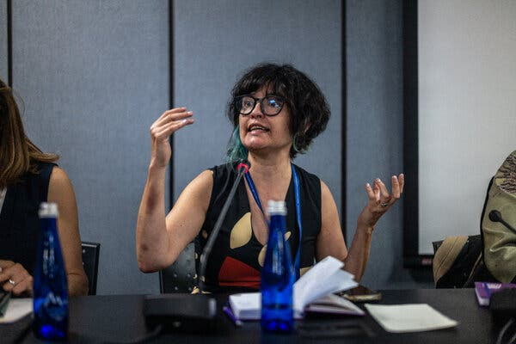

Speaking at the July 4 panel in Cartagena.

**A Diagnosis**

In July 2023, after a hiking holiday with her husband, Ms. Andia went to a doctor in Bogotá about a sharp pain in her back. Tests revealed that the cause was tumors encircling her spine — metastases of an incurable lung cancer.

She found herself in the office of Dr. Andrea Zuluaga, an oncologist, who described treatment options that might extend her life. Ms. Andia had a different question: People who have this, how do they die?

Dr. Zuluaga looked taken aback. But she answered frankly: It’s a lung cancer, so mostly they asphyxiate.

“That didn’t sound great,” Ms. Andia recounted later, her understatement punctuated with a big laugh.

Avoiding that became her goal. The question was how to do it. How could she die, with the least amount of suffering, and while she could still control the process?

When she was recruited to the health ministry in 2014, she was excited to join colleagues who were wrestling with sensitive social issues. Some were trying to expand access to abortion, a longtime battle. Others had been tasked with something new: introducing physician-assisted death to the national health system.

**The Final Choice**

This article is the second in a series about medically assisted death around the world. Read the first:

[She’s Trying to Stay Ahead of Alzheimer’s, in a Race to the Death](https://www.nytimes.com/2025/02/16/health/assisted-death-alzheimers-netherlands.html)

[Feb. 16, 2025](https://www.nytimes.com/2025/02/16/health/assisted-death-alzheimers-netherlands.html)

Medically assisted death had been decriminalized in the country in 1997, but no Colombian government wanted to write the law that would allow such a controversial practice. The issue languished until 2013, when the country’s highest court — pushed by a second, frustrated, terminally ill patient — ordered the health ministry to draft regulations right away.

Ms. Andia supported her colleagues’ work on assisted death without giving it much thought. She believed in autonomy and choice, but she was healthy and in her 30s; rules about how people could die didn’t seem to have much to do with her.

Her focus, instead, was leading a push to cap the price of essential medicines for the public health service, a priority for the health minister at the time, a young, left-leaning economist named Alejandro Gaviria who was new in the role. The regulations Ms. Andia put in place, in the face of fierce resistance from the pharmaceutical industry, became a model for other developing countries.

Image

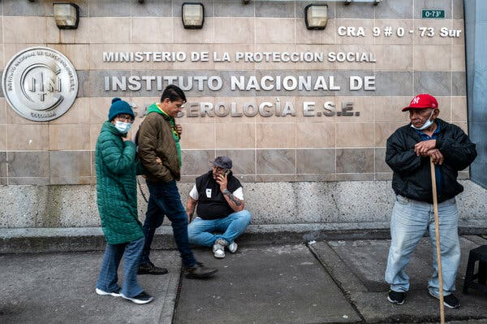

The National Cancer Institute in Bogotá.

Image

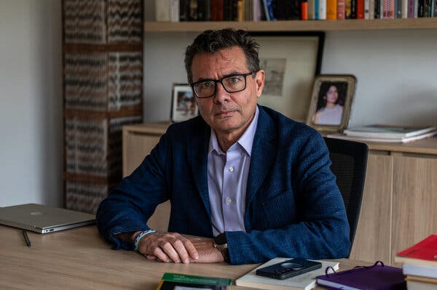

Alejandro Gaviria, the former health minister, in his office.

After that victory, she left the ministry and became a professor of sociology at the prestigious Universidad de los Andes. Assisted dying rarely crossed her mind — until she found herself confronting a terminal cancer at 43.

Colombia’s rules for assisted death, she knew, were among the most expansive in the world; the procedure is allowed for patients — even children — with unbearable suffering, whether their illness is terminal or not. So there was no question she would be eligible to have a physician end her life when she wanted to.

But that didn’t mean she knew how to go about it. Few Colombians did. Because it came about by court order, and not legislation, it wasn’t the subject of broad public debate. Doctors, uncomfortable with ending lives and reluctant to give patients so much control, hadn’t encouraged it, and by 2023 only one in three hospitals had established the required review committees. And health insurance companies, which nominally have the job of organizing assisted deaths, are so bureaucratic that people die of their illness or give up before they get access.

As a result, assisted deaths remain rare. Between 2015 and 2023, the last year for which data has been released, [there were a total of 692 medically assisted deaths](https://www.desclab.com/post/eutanasiacifras) in a country of 53 million people.

Within a month of her diagnosis, Ms. Andia decided she would chronicle her path to death. She began writing a newspaper column and appearing regularly on podcasts and TV talk shows. She viewed these efforts as one more way she could broaden health care access by demystifying the assisted dying process, and bringing it into public conversation.

“A person can die in a dignified way,” she said on one popular Sunday night TV show. She sketched out the steps she had taken since she learned about the cancer to ensure she could die before she was too debilitated. “That made me calmer. So that’s the plan.”

**Red Lines**



Sunset in Cartagena, Colombia.

Ms. Andia drew up her “red lines,” the non-negotiables. She would not allow surgery on her brain. She would not undergo chemotherapy, which would weaken her without significantly extending her life.

She felt freer to make these decisions because she did not have children, she said; if she had, it might have muddied her clarity. She would die before she lost her physical autonomy, before she lost her ability to think clearly, before she had no choice but to depend on other people.

But there was a treatment she agreed to try: an immunotherapy that might buy her some time. It was a daily pill with limited side effects. It cost the Colombian health service $1,700 a month (she looked it up, of course) rather than the $10,000 it costs in the United States, because of the drug pricing reform she had helped bring about.

For seven months, that drug held the cancer in check. Ms. Andia took leave from teaching, as did her husband, Andrés Molano, also a professor. They traveled to see friends, threw parties, drank wine on their terrace and danced salsa, pressed tightly together.

Ms. Andia said she was consciously packing as much life as she could into her days, although it was hard to know just how frantically to do it: for people on the drug, the statistical models predicted a year of survival on average, but her doctors told her of some who lived for five or six years.

In February 2024, she began to have headaches so excruciating she could not say her own name. The vision in her left eye began to narrow. Tests confirmed that the therapy had stopped working, and there were now tumors in her brain.

Dr. Zuluaga, her oncologist, wanted her to have radiosurgery, a targeted radiation aimed at the tumors in her brain, which might stop the headaches and buy another pause. She agreed even though she had previously ruled out procedures on her brain.

“If I’m having fun, and a good quality of life, why not have an extra trip and go and see my nieces and my family and friends?” she said in May 2024. “Another hug — who wants to skip another hug?”

Image

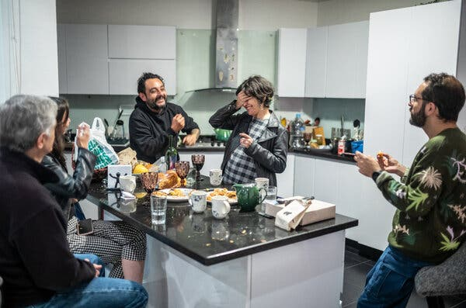

Hosting friends last July.

Image

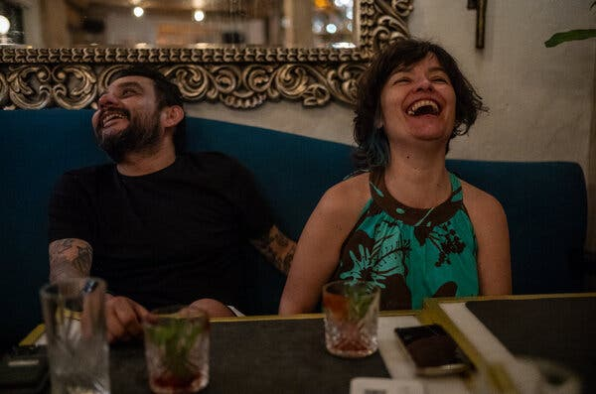

At dinner with her husband, Andrés Molano.

Yet she found herself in a constant negotiation with her doctors, and she struggled to make them understand that her goal was not to live every possible extra day. At one point, Dr. Zuluaga wanted her to have another round of the radiosurgery immediately, but Ms. Andia had a trip planned and refused to cancel it.

Dr. Zuluaga disapproved. “She said in a very harsh tone, ‘I don’t know if I made myself clear enough that this is urgent,’” Ms. Andia said.

Ms. Andia wanted to reply: “‘Yes. You made yourself clear enough. I just decided something else. And I’m happy with my decision.’ And I have all this pain now, and who cares? I was happy.” But she couldn’t bring herself to say the words aloud, even though she knew it was the type of conversation that needed to happen more.

Her doctors suggested a new drug. There was only a one-in-four chance that it would buy her more time, and she was stuck on the cost to the health system: about $10,000 a month. She learned that it was patented and produced by AstraZeneca, but based in large part on research that had been done in publicly funded institutions. It was, in other words, exactly the kind of drug pricing situation she despised.

“I know the trade-offs,” she said. “I know what $10,000 per month per patient treatment would imply for the health care system in terms of other things that it would have to stop doing.” She wouldn’t take it.

Her father, a doctor and longtime activist against high drug prices, and her brothers supported her position. (Her mother had died a few years earlier, but would have concurred, she was sure.) But friends tried to change her mind, saying that she had earned the opportunity to take the drug because of the money she had saved the health system by negotiating the price caps, or because of her value as a professor and a public servant.

Ms. Andia shuddered at the idea that some assessment of her worth should determine how she got care. “What kind of a crazy place are we in, if we start doing that?”

In the evenings, over bottles of red wine, she and her husband argued the ethics. She came at it like a debater; he struggled to control his feelings. One evening, he paced back and forth from the dining table to the terrace, taking slow, deep breaths, before returning to the discussion.

The conversation about what a life is worth was the wrong one, Ms. Andia said.

Instead, she said, it must be about what the drug was worth. She wanted to confront AstraZeneca, and ask what the company spent on research and development and clinical trials.

“You’re not Joan of Arc,” Mr. Molano told his wife, exasperated.

She narrowed her eyes at him.

“Why would I do this, as if I’m so concerned to have another six months of life,” Ms. Andia said. “What does that get me?”

“One fun day?” he replied.

“I’ve had that,” she snapped.

He headed for the terrace.

A bit later, he returned. “But one month more of you bitching about this — I’ll pay for that,” he said.

Several months later, she began to take the drug.

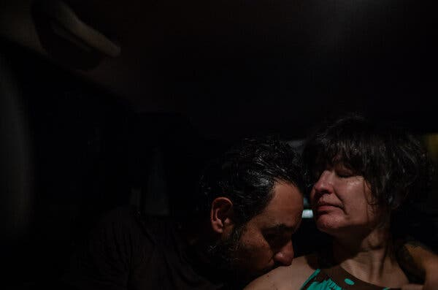

In a taxi on the way home from dinner with Mr. Molano.

A year into her disease, Ms. Andia had to rely on Mr. Molano more and more. On the morning of her speech in Cartagena, she tried to put on a favorite jumpsuit and became hopelessly tangled in it because her left leg was increasingly numb. She threw it across the room in a rage and wept for a while.

Mr. Molano helped her into a dress that slipped easily over her head, then bent down to tie the ankle straps of her espadrilles. When she got into the elevator, there were faint tracks of tears on her cheeks.

From the table where she spoke, she tried to make eye contact with everyone in the room, but by now she could no longer see from her left eye, and one side of the crowd was invisible to her.

She thought this sort of dependency would be intolerable, but she still wasn’t ready to die, even as it fell to Mr. Molano to gently steer her around obstacles and push the food on her plate to the right. Her legs were splotched in bruises from bumping into things.

She could no longer type, and had to send her family audio messages. She wrote her newspaper columns by dictating into the notes app on her phone, in bed with her cats — one of whom stole the cheese from the side of the plate she could not see.

On the sofa, she received waves of visitors, and observed how some were ready to join her in thinking about when to end a life — while others made cheerful conversation about whether she might return to teaching next semester.

Her friend Mr. Gaviria — the former health minister who oversaw the introduction of assisted death in Colombia, a cancer survivor himself who wrote a book about mortality and the need to talk about death — joined her for regular lunches. He read her columns. But he didn’t ask about the plan for her assisted death.

“I’ve been very shy about this,” he told me. “I don’t know why. It’s the human heart.”

He laughed and shook his head. “I don’t practice what I preach,” he said. “I don’t want the moment that she’s going to tell me, ‘You know what, I have weeks.’”

Image

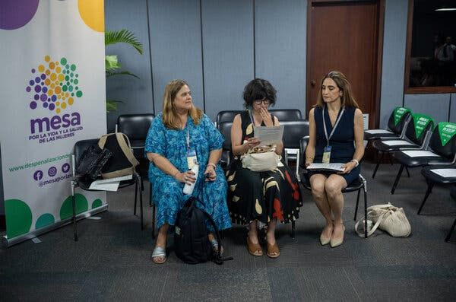

Preparing her remarks for the panel in Cartagena in July 2024.

Image

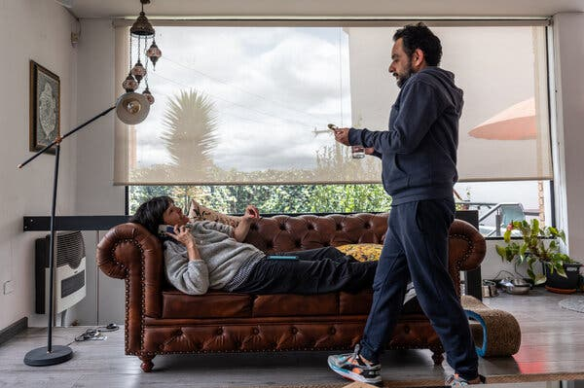

Mr. Molano brought painkillers for a headache.

Ms. Andia was deep in the bureaucracy of dying by now. She had requested that her health insurance company organize her assisted death, but no one answered her calls or emails. She dug out the phone number of a senior executive she had known in her ministry job, and told him bluntly that her request to die was being stalled.

After that, her file moved forward quickly. She wrote in a column that she knew most patients would not have her connections, her profile or her knowledge of the system.

In August, Ms. Andia had a severe seizure. At the hospital, doctors told Mr. Molano and her father that they would need to intubate her, or she would die. The two men were distraught: she had a clear “do not resuscitate” request and was in the process of applying for an assisted death. But that kind of advance planning was so rare in Colombia that the doctors started the intervention. They only stopped at the last moment when Ms. Andia’s oncologist burst into the room and insisted.

For a fraught half-hour, it seemed that it was the end, but Ms. Andia regained consciousness. A psychiatrist was summoned to evaluate her. She was deeply debilitated, but managed to show him, on Mr. Molano’s phone, that she had been writing about her intention to die for more than a year.

He authorized her right to decline treatment — and, almost as an afterthought, to have an assisted death, one of the three approvals she needed from independent experts (the others were from a lawyer and an oncologist).

Ms. Andia’s recovery from the seizure was painful and slow; she felt as if she were trapped in a deep bag, she said, and unable to join conversations. “There are no good days, only bearable days,” she said. Still, she did not set a date to die.

By January and the turn of the year, the borders of her world had shrunk in close. What haunted her now was how the people closest to her, her husband and father and brothers and nieces, would cope with her death. Thinking about how they would experience that day was crushing, the dark image in front of her eyes when she opened them each morning.

Yet she felt urgency to act before she lost the ability. She had the paperwork to allow Mr. Molano or her father to request the procedure when she no longer could, but she would not put them in that position. “I want them to be fully, completely happy that I was the one who chose to die in the way that I want to die.”

Irritated with the insurance company, where a bureaucrat wanted to assign her to a random doctor and dictate the time and date of the procedure, she shifted her request to the hospital where her cancer had been treated, hoping she would have more control.

Image

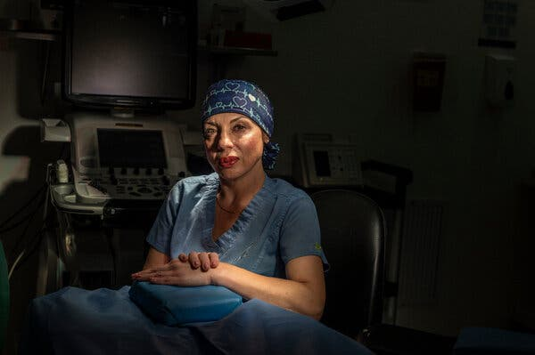

Dr. Paula Gómez, a cardiac anesthesiologist in Bogotá.

Most assisted deaths are for patients with cancer, but even at Colombia’s national cancer hospital, Ms. Andia’s oncology team did not know how to arrange the procedure. Once again, she had to rely on her connections to speed the process. Her request was assigned to Dr. Paula Gómez, a cardiac anesthesiologist at the institute who performs almost all the assisted deaths there.

Dr. Gómez was startled when she learned, just a few years earlier in a medical law class, that assisted death was permitted in Colombia. At first, she was repelled by the practice. Doctors, she said, are not meant to be “executioners.” But gradually she began to feel that ending suffering could be the ultimate act of care.

She started performing assisted deaths at the institute, one every few months. She has grown more comfortable with it, she said, even though her colleagues still won’t meet her eyes when she arrives on a ward for a death.

But Ms. Andia wanted to die at home. In early February, when she told the hospital it was time, administrators realized they didn’t really know how that would work. There were days of scrambling, while Mr. Molano made increasingly desperate calls to the hospital.

By then, Ms. Andia was plagued by excruciating pain, her bright mind dimmed by the powerful medications that never fully blunted the ache from the tumors. She could follow the process, but barely.

She found herself making lists of the things she had lost — the ability to make her way down her spiral staircase; to lift a cup of strong coffee to her lips; to fire off a sarcastic text message; to dance with her body pressed to Mr. Molano’s — to try to justify why she was, finally, choosing to die.

**Her Last Wish**

Image

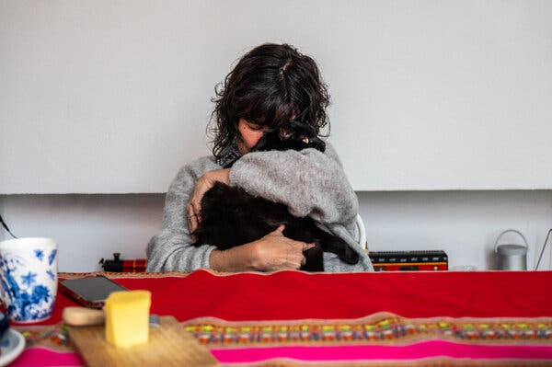

Breakfast with Ramiro the cat last July.

Ms. Andia published her last column on Feb. 26, under the headline [“Se Acabó La Fiesta”](https://www.elespectador.com/salud/se-acabo-la-fiesta-la-ultima-columna-de-tatiana-andia/#google_vignette) — the party is over. “I myself oversimplified euthanasia,” she wrote. “But it is not so easy, it is not just a formality. Like many other fundamental rights, it is good and reassuring that it exists on paper, but exercising it in practice is another story.”

By then, tens of thousands of Colombians were following her story, watching her navigate the shifting red lines. She wanted them to know that she was drawing the last one.

“The party is over, precisely because it stopped being a party and became an ordeal. And I don’t have to show anyone how much I suffer,” she wrote. “I bow out with dignity.”

That same morning, Dr. Gómez buzzed at the gate of Ms. Andia’s home. Inside, she climbed the spiral stairs and came into the bedroom, where Ms. Andia lay with one of her cats snuggled by her neck. The room was filled with roses from her brother’s farm and one of her favorite songs — “[I’ll Catch You](https://www.youtube.com/watch?v=BwaY-wqeKGQ),” by the band the Get Up Kids — played on repeat from the stereo. Ms. Andia’s father and two of her brothers sat nearby. Dr. Gómez introduced herself.

“Tatiana, I’m Dr. Paula,” she said, “and I’m here for your last wish.”

Ms. Andia’s brother Boris sang children’s songs, and Ms. Andia’s thin voice faded in and out in a weak duet. Her father cradled her one last time and left the room. Her husband lay down beside her and took her in his arms. Dr. Gómez placed an IV line in Ms. Andia’s forearm and injected first a sedative, then a medication that stopped her heart.

That evening, her death was reported on Colombia’s national news. It was in every newspaper. Her career was celebrated. None of the stories mentioned she had died an assisted death.

Image

