Family Practice

A Family Doctor’s Search for Salvation

*Instead of turning inward after the death of his son, Dr. Greg Gulbransen turned outward: toward documentary photography and people whose lives he might be able to save.*

**By**[**Joshua Rothman**](https://www.newyorker.com/contributors/joshua-rothman)

July 14, 2025

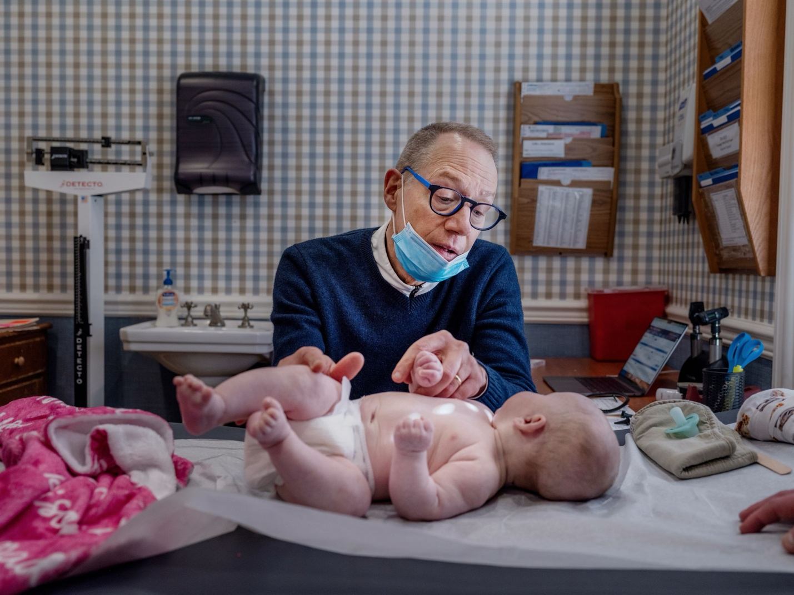

After accidentally killing his toddler son, Gulbransen (seen here examining a patient at his practice in Oyster Bay, Long Island) set out to help not just patients but strangers. “Feeling needed, feeling useful, feeling important—they’ve helped me hide the demons,” he says.Photographs by Natalie Keyssar for The New Yor

The Mott Haven Houses, in the Bronx, are orange brick buildings about twenty stories high. The stairwells are dangerous, the elevators slow; Greg Gulbransen, a pediatrician from Long Island, waited in the lobby, bouncing with impatience. Even at dawn, he was pressed for time. It was six-thirty, and he needed to get back to the suburbs to see patients by nine. “Let’s hope we can find him on our first try,” Gulbransen said.

He was looking for Red, a former tattoo artist in his early thirties who was addicted to drugs and now drifted between hideouts in and around the Mott Haven projects—an abandoned construction site, a janitor’s closet, a stairwell to the roof. They had met about a year earlier, when Gulbransen was on his way to see Malik, a onetime gang member who’d been shot and left paralyzed below the chest. A photographer as well as a physician, Gulbransen had been documenting Malik and his circle since 2019, for a series about gun violence and its aftermath. When Red approached him on the street, hoping to sell scavenged goods, Gulbransen noticed his inked-Brando look and asked to photograph him.

Gulbransen is sixty-two and slim, with white hair and blue-framed glasses. He runs five miles with a headlamp every morning; now he darted, as if spring-loaded, through the opening elevator doors. He checks on Red nearly every weekend. This Sunday, he planned to buy him breakfast, offer encouragement and medical attention, and deliver a bag of clothes donated by families from his practice—along with some pillows he’d taken, without his wife’s permission, from a room that was being redone. (“Don’t tell Leslie,” he’d said earlier.) Most of Red’s acquaintances are drug-addicted and on the edge of a fatal overdose; Red is essentially alone in his efforts to save himself, except for Gulbransen, who is part doctor, part social worker, part father figure, part friend. Whenever Red texts, Gulbransen answers.

Leaving the elevator, Gulbransen swept down a sallow hallway to a closed green door. A sheet of paper—an index page, torn from a book—was wedged into its ventilation grille to keep out light.

“Red, it’s G.,” he whispered loudly, knocking. “You in there?”

A dog barked somewhere down the hall. A woman in scrubs was heading out to work. Behind the door, Red groaned, then gave himself a self-motivating shout. After a minute, he emerged, groggy and exhausted, brow furrowed. Months earlier, Gulbransen had captured Red’s charisma in a moody portrait he’d posted to Instagram. “Moms in the practice always ask, ‘How’s Red?’ ” he’d told me, laughing. But lately Red’s health had declined; he was thinner, unsteady on his feet. “How’s your leg?” Gulbransen asked. “You fall down again?” He took Red’s arm, checking his wrist—the same bedside manner I’d seen him use with my kids, who were also his patients.

I’d met Gulbransen six years earlier, when my wife and I were expecting a baby and looking for a pediatrician near our seaside village on Long Island. “I am obsessed with him,” a friend wrote in an e-mail when we asked for recommendations. A little Googling revealed that Dr. Greg, as our friend called him, was not a typical physician. He worked in a cute converted house in Oyster Bay, but his website featured photographs from a fashion editorial he’d shot for a European edition of *Elle*. My wife, whose Googling went further, discovered something tragic: in 2002, he’d accidentally killed his two-year-old son, Cameron, by backing over him in the driveway. Afterward, he spent years crusading for legislation requiring back-up cameras in all new cars. The Cameron Gulbransen Kids Transportation Safety Act passed in 2008; the cameras became mandatory in 2018. Our car had one.

“I really have a lot of respect for him,” our friend had written.

I’d been fascinated by Gulbransen. On his practice’s Instagram, I watched him tickle babies and explain the importance of vaccination; he had an easy rapport with children and parents, and was clearly a capable and well-loved pediatrician. Yet beneath his ebullience there was an intensity that drew me in. Even as a prospective father, I was beginning to grasp the role that fear plays in parenthood; a feeling of supreme responsibility was settling in. My wife’s family had given us an old bassinet—an heirloom of white-painted wicker in which two generations of babies had slept—and I’d created some drama by refusing it. It didn’t meet modern safety standards; I pictured our son on his stomach, his nose and mouth trapped between mattress and frame. I didn’t want to kill our baby—that was the bottom line. I tried to imagine what it had been like for Gulbransen to live through the central parental nightmare. I wondered how it had affected him, and his doctoring. Had it made him especially understanding of his patients’ anxieties? “He never made me feel awkward for asking questions in the middle of the night,” our friend had written. “First time mom things. . . . You’ll understand.”

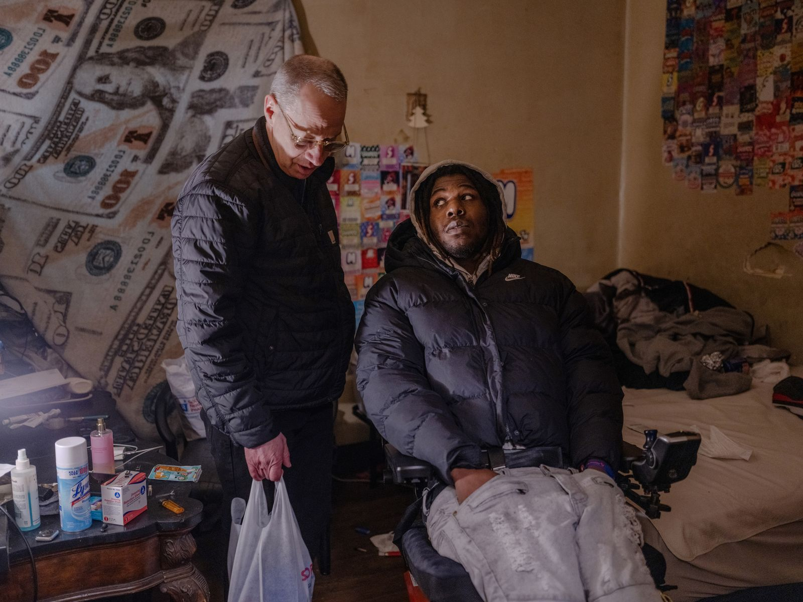

In 2019, Gulbransen began photographing Malik, who’d been shot and left paralyzed below the chest, for a project about gun violence. The pictures were published last year in a book, “Say Less.”

A stairway led to the roof, and Red took us up to find his friend K.B., who was sleeping at the top on a folded piece of cardboard. Red invited him to breakfast; while he and K.B. got ready, Gulbransen ambled to the railing. The day was overcast, the rooftops of the Bronx extending toward the gray water in the distance. “Some of the families in my practice own buildings you can see from here,” Gulbransen said. “That one, and that one.” He’d spent a lot of time lately on project rooftops, befriending a few couples—all addicts—who lived there. He was working on a photo series about them. He pointed out a spot where one couple sometimes slept; I walked over and found an empty syringe next to a single red ballet flat.

Good people are often puzzles to those of us who wish we were better. We try to understand what they do, and how, and why. Many base their goodness in principle, or faith, or some vision of how the world ought to be, and we sometimes suspect that, if we could only adopt one of their systems, we might do good, too. But Gulbransen’s goodness wasn’t part of any system; it was personal, even arbitrary. There were, I learned, many Reds and Maliks—many people with whom he’d forged one-to-one relationships of care. Some were in the Bronx, others farther from or closer to home. He’d begun making these connections after Cameron’s death, and, over time, they had become a way of life. In the Old Testament, when [Job laments his fate](https://www.newyorker.com/magazine/2013/12/16/misery-3), a friend tells him that “man is born unto trouble as the sparks fly upward.” We all suffer, as inevitably as a fire throws off pieces of itself. But Gulbransen had built something from his sparks.

Advertisement

He turned to check on the men, peering through a cracked window at the top of the stairwell, and told me, “Red does tranq”—a powerful tranquillizer called xylazine mixed with fentanyl. “If he doesn’t get clean soon, he’ll die. I’ll come down here one day and nobody will have any idea where he is, and he’ll be buried in a potter’s field.” He shook his head, then shook it again, as if to snap out of the thought. It was ten to seven. Red was just one of many patients he needed to see. “Let’s get breakfast!” Gulbransen called, heading inside.

The hamlet of Oyster Bay, on the North Shore of Long Island, is pleasant, verging on twee. There’s a beachside park with a snack bar, and a town common where you can buy Italian ices from a stand that’s been open for a hundred and twenty-eight years. [Billy Joel](https://www.newyorker.com/magazine/2014/10/27/billy-joel-profile-thirty-three-hit-wonder) owns a vintage-motorcycle shop. [Teddy Roosevelt](https://www.newyorker.com/tag/theodore-roosevelt)’s “summer White House,” Sagamore Hill, is a short drive from the high school. On Tuesday nights in the summer, old guys parade their classic cars. Some parents in Gulbransen’s practice sail at the Seawanhaka Corinthian Yacht Club; a few are celebrities or hedge-fund billionaires. But most are middle class, and about a third of the charts in his office’s filing cabinets are blue, indicating Medicaid. The town is a jumbled American place.

Video From The New Yorker

[Swift Justice: A Taliban Courtroom in Session](https://www.newyorker.com/video/watch/the-new-yorker-documentary-swift-justice-a-taliban-courtroom-in-session" \t "_blank)

Gulbransen’s office has a relaxed, even buoyant, vibe and a homelike floor plan. A doorway from the porch faces the reception desk; a hallway leads past well and sick waiting areas. A Pinewood Derby racecar hangs upside down from the ceiling of the well area. In the sick area, photo collages display hundreds of smiling patients, from infants to young adults. Gulbransen’s practice handles around twenty thousand visits a year, but his team is small and the quarters are close. Working in the exam rooms in the back, Gulbransen is able to call out and greet arriving families by name.

Not long ago, my wife and I brought in our daughter, Alice, who’d been out of sorts for a couple of weeks. Gulbransen, who has a slightly impish demeanor, burst in: “Hi, Mom! Hi, Dad!” He chucked Alice under the chin, grinning even as she wailed. (She’d learned to anticipate a shot.) “Crying is good,” he reassured us. “Visits are always combative at eighteen months.” He gently laid Alice on the exam bench, teased open her mouth, and showed us four molars coming in at once. “She’s perfect,” he declared. “You guys are doing great.” In general, he likes to boost parents’ confidence in their own instincts. Five years earlier, after examining our newborn son, Peter, he’d told us, “You got this.” Waggling his eyebrows, he’d asked, “What’s the biggest determinant of pediatric health?” When we hesitated, he said, “Zip Code!”

[](https://www.newyorker.com/cartoon/a27814)

*“O.K., does anybody have any conflict-resolution strategies that aren’t spraying liquid from your anal glands?”*

Cartoon by Ellie Black

Copy link to cartoon

Link copied

Shop

Open cartoon gallery

Gulbransen grew up ten minutes away, in another waterfront town, Glen Cove. A natural with kids, he taught phys ed and science before becoming a doctor. He bought the practice from two other pediatricians in 1999 and set about building it up with a new father’s anxious zeal. The accident happened on an October night. Around nine-thirty, Gulbransen and Leslie returned to their condo after dinner with friends. The babysitter had already put Cameron and his older brother, Scott, to bed. But Cameron called out, and Gulbransen went upstairs to check on him. The boy was sitting up, smiling and holding his blue blanket. Out on the landing, he threw himself into his father’s arms. “I remember that hug,” Gulbransen told me. “There was something intense about it.”

He carried Cameron downstairs to hang out until a new bedtime could be contrived, and watched as he ran toward the babysitter and Leslie. Then Gulbransen went outside, closing the front door and a screen door behind him, to move the family car from the street to the driveway.

Cameron had seemed to be with the other adults, and had never before left the house on his own. Gulbransen is organized and meticulous—he doesn’t drink and is so energized he avoids even coffee—and he checked his mirrors before backing in. But, as he reversed, he felt a bump near the front wheel. He leaped out to find Cameron on the ground, in the headlights, clutching his blue blanket and bleeding from his head. As a doctor, he knew instantly that Cameron was dead. Still, he performed CPR, tasting his son’s blood in his mouth.

“There are actually scales that psychiatrists use to quantify life stress,” he said. He recalled one from medical school: “ ‘Have you lost a job? Are you divorced? Have you lost a child?’ They don’t even talk about ‘Have you killed your own child?’ That’s not even on the list.” He told me this on the second floor of his office, in a sitting room he’d redecorated about ten years ago, after the practice had reached a stable level of success. Surrounded by photography books, four American Girl dolls regarded us from an alcove. In the community, the accident has given Gulbransen a special role; families who suffer traumatic losses sometimes seek him out. He gives the dolls to their children.

Leslie is Jewish, so Cameron’s funeral was held three days after his death. Anguished and ashamed, Gulbransen saw a therapist who advised him to take a few weeks off. Instead, he went to work the next day. Flowers were heaped on the steps to the office. A postman, passing by, asked what they were for.

“I have no idea,” Gulbransen said, hurrying inside.

He told the surprised staff that he was ready to see patients. A mother waiting in the exam room had heard what had happened—everyone had—and stared at him in silence. “Then I said, ‘Let’s go,’ ” he recalled. “And everybody just knew, Don’t talk about it. And I just started working hard.”

Therapeutic workaholism is part of Gulbransen’s altruism. Ever since the accident, he said, he’d struggled with the feeling that he didn’t deserve to be alive when Cameron was dead. “You’re constantly, constantly asking yourself, ‘Are you good enough?’ ” he told me. “That’s why a lot of people turn to drugs or alcohol after these accidents, or get divorced.” (He and Leslie are happily married; their daughter, Julia, was born the year after Cameron died.) “I’m lucky to have this office, where I can keep reaffirming that I’m good enough for kids,” he went on. “It becomes a dopamine drip.” He almost never takes weekends off, and his vacations are rare, indulged in to please his family. The dopamine wanes. If Gulbransen doesn’t do something of value once or twice a day, he starts to ruminate. “Feeling needed, feeling useful, feeling important—they’ve helped me hide the demons,” he said. He told me how, on a recent day, he’d correctly diagnosed four kids with pneumonia: “Drip.” Mothers marvel at how he makes house calls on Sundays. If you text him late at night, he replies.

In the Bronx, we descended to the street, and Gulbransen, mindful of the clock, set a fast pace. Red and K.B. staggered behind and reminisced. Red had been born addicted to opiates; he’d built a life, which went off the rails after his girlfriend overdosed. Not long ago, he’d run into her mother. “She still sees something in me,” he said, in a thoughtful tone. “I don’t see it. But I’d like to be the person she sees.”

“You got this, buddy,” Gulbransen said. “You’ll get out of this.”

At a bodega, the men ordered breakfast. Gulbransen helped Red pick out some basics—a T-shirt, some packets of Pedialyte—and paid. We headed for a park where they could eat. Near the empty, sunlit basketball courts, a big flat-screen TV sat incongruously on a bench, its power cord coiled around it like a tail.



On many weekends, before work, Gulbransen finds addicts like Red (right) and Veronica (left) and buys them breakfast and other necessities.

“Holy shit!” Red said. It was as though we’d found a treasure chest. He sidled up to the TV, widened his arms, and hefted it. He looked at Gulbransen: “G., do you mind . . . ?”

Advertisement

Gulbransen nodded, and Red and K.B. began grappling with the television. “Someone probably stole that yesterday, came here, got high, and forgot about it,” Gulbransen said, sotto voce. “That’s how they live. They find stuff, steal stuff, sell it. It’s day to day.” (I was reminded of Gulbransen’s dopamine drip.) He watched, bemused, as Red and K.B. carried the TV around a corner.

At the time of the accident, Gulbransen owned a camera but had taken only one “good” picture of Cameron, in which the boy wears an uncertain expression and a blue baseball cap with an American flag. “He hated that hat, but he gave me that look and I took that picture,” Gulbransen said. “I wish I had more pictures of him. I wish I could have told his story.” He vacillates on the value of story. “There’s obviously something greater going on here,” he told me once. “People don’t like hearing this stuff, but I guess he and I were meant to tell the story, to help make the world safer for other people and other children.” But he can also take the opposite view—that Cameron’s death was a meaningless accident. Therapy had helped him see that stories can be traps: “We think that we’re in control, so it’s easy to feel guilty rather than come to terms with the fact that we’re really not.” And yet, he went on, “it certainly is my fault. The operator of the vehicle is responsible no matter what happens.”

Fundamentally, Gulbransen finds solace in stories. Recalling his early years, he noted that he was the third of five children and that, not long after he was born, his eldest brother died when a Coxsackievirus infection reached his heart. “So I grew up in a house where there was a child that died,” he said—maybe that was part of why he’d become a pediatrician. His mother cooked meals for local needy families; his father, an advertising executive who “worked like a machine,” had driven tanks in the Second World War and, at twenty, participated in the liberation of Dachau. The experience left him with a hatred of bigotry, and he helped organize field days in which Glen Cove’s well-off white kids played with Black kids who lived in affordable housing. Gulbransen keeps photographs his father took at the camp. “It was my Dachau,” he said of Cameron’s death. “Ultimately, it was my responsibility. If something’s your responsibility, you have to ask, ‘What’s your response?’   
Red and K.B. returned, sat, and started their breakfasts. Gulbransen stepped back, pulled his camera from beneath his jacket, and took a picture.

It was a little after eight: time to go. We handed over the clothes and got in the car. Gulbransen drove fast; forty minutes later, we’d traded the Bronx’s concrete for the woods, beaches, and gated villas of northern Nassau County. At the office, with minutes to spare, he ducked in through the back, stepped into a small side room, and sprayed himself down with Lysol. Then he strode past the waiting areas to the front desk, where a receptionist had set out the first patient charts. He introduced me to her, noting that she’d grown up in the Mott Haven projects. Her story had ended well.

“How’s Red?” she asked.

My grandfather was a pediatrician, in a small city north of Boston. As a kid, I visited his office and even got a few physicals, but never really thought about what his job entailed. Not long ago, on a Wednesday afternoon, I met Gulbransen for lunch (“Dr. Greg!” a group of women called, from their booth), then drove with him to visit Eliza Franson, a mother whose fourteen-year-old son, Thor, has Duchenne muscular dystrophy, which will likely claim his life within a decade. We sat in the kitchen listening to Thor play Billy Joel and [Van Halen](https://www.newyorker.com/culture/postscript/eddie-van-halens-otherworldly-sounds) on an electric piano. He was prodigiously talented. Gulbransen helps with Thor’s care, but this visit had no particular purpose; he was just checking in.

“Everything good?” he asked Eliza, after half an hour.

“Well, you know,” she said.

Later, I heard about a twelve-year-old boy in the practice who’d suffered a severe eye injury while horsing around at home. Gulbransen had phoned the E.R. to make sure they had an ophthalmologist ready. For days, everyone in the little house in Oyster Bay was on edge, fearing that he’d lose his sight in the eye. They’d known the patient since he was a baby. When the treatment succeeded, they exhaled.

The seriousness of pediatrics shouldn’t have surprised me, but it did. Kids get hurt and get sick, like anyone else; every year, a few in the practice battle life-threatening illness, often cancer. Gulbransen wasn’t comfortable with death, exactly, but he was comfortable talking about it. As part of his push to pass the Cameron Gulbransen Act, he’d told the story of the accident many times—even before Congress. This was another aspect of his altruism: instead of turning inward after tragedy, he’d turned further outward, and stayed that way.

As the back-up-camera project was coming to an end, he needed something to fill the void. His father had once taken him to the beach to look for a snowy owl, so Gulbransen set out to photograph one. Then he started travelling to Alaska to take pictures of grizzly bears. He attended workshops in food and fashion photography. Eventually, he realized he mostly wanted to photograph people. He made elaborate “hero” portraits of disabled patients as gifts for them and their parents. (He photographed Thor as the boy leaped into a pool; to challenge himself, Gulbransen took the picture underwater, wearing scuba gear.) After reading about people trying to leave the Ku Klux Klan, he found one of them online, then travelled to Indiana to photograph him—helping pay for the removal of his racist tattoos. In West Virginia, he simply drove around until he met a family, then photographed them, bought them groceries, and provided medical advice for their kids. What was he doing? Where was it going? He didn’t overthink it. In a way, not thinking was the point.

Leslie was used to Gulbransen’s enthusiasms. “He’s always been intense, and involved in things,” she told me. “I think that’s what attracted me to him in the first place.” Still, she wished he’d stay closer to home, and so he decided to visit the Bronx Documentary Center, on 151st Street, to learn about photographing city life. Before even going in, he got to talking with some kids on bikes. They turned out to be members of the Charged Up Ryders, an anti-gun youth bicycling gang. Gulbransen spent four years photographing them—also assisting with their pediatric care, buying them gloves in winter, and paying for bike repairs. At one point, he impressed them by riding a unicycle. He noticed that a surprising number of them had been shot. Eventually, through them, he met Malik.

[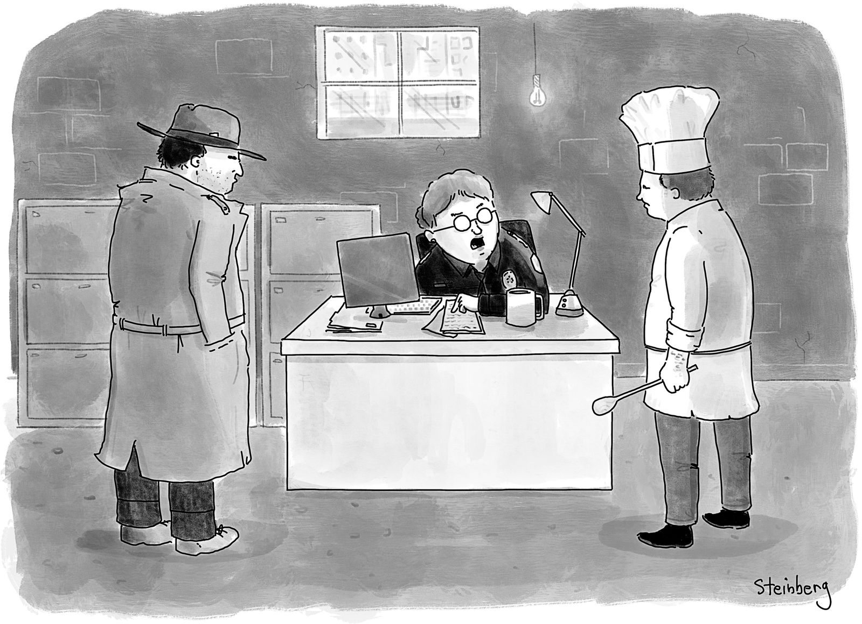](https://www.newyorker.com/cartoon/a26684)

*“You, follow the money, and you, follow the recipe.”*

Cartoon by Avi Steinberg

Copy link to cartoon

Link copied

Shop

Open cartoon gallery

I first heard about Malik during a routine appointment for Peter. “I gotta show you these pictures,” Gulbransen said, pulling out his phone while Peter babbled in my arms. He swiped through black-and-white photographs of young men who’d been shot and lived with the wounds, along with their families, apartments, and hangouts. “This is where Malik got shot, right here,” he said, pointing to a street corner, not quite explaining who Malik was. He made a pistol with his hand: “They just went *bam, bam, bam!*” He paused at an image of Malik being lowered, tenderly, into a bathtub by a pair of large men. “He was a real tough guy before,” Gulbransen said. “I bring him catheters and stuff.”

Advertisement

At another appointment, Gulbransen showed my wife a fuller series of photographs, which he’d assembled into a book titled “Say Less.” To his delight, it had been accepted by a respected photography press. The pictures mapped a confined world of battered hallways and dim bedrooms where men showed off guns and scars. Many images had a medical sensibility, focussing on the labor of caregiving and the mechanics of wound care. In one, a man in a ski mask lifts his shirt to reveal a colostomy bag. In another, Malik—who rarely leaves his apartment, lest his shooter try again—attempts to navigate a tight corner in his motorized wheelchair. Where a footrest keeps hitting the wall, there’s a hole. “It shows he’s trapped,” Gulbransen said. “They’re all trapped.” He recognized himself in Malik, who, he said, had also been both a perpetrator and a victim of violence.

Upstairs in the office kitchenette, Gulbransen FaceTimed Malik to check in. “Did you finish work today?” Gulbransen asked. (Malik, as part of a youth program called Graffiti, mentors kids by video chat.) “How’s your phone bill?” (Gulbransen often pays it.) He’d bought Malik an air-conditioner, then connected him with a well-off mother from the practice, who bought the family a freezer. “Did you put that food in the freezer?” he asked.

“Love you, Greg,” Malik said before hanging up.

Gulbransen frequently uses a wide-angle lens, making small spaces look larger; maybe that’s why I was surprised by how cramped Malik’s apartment was when I accompanied Gulbransen there. In a tiny back room, Malik lay in bed, watching hip-hop videos on television and scrolling on his phone. “I got you enough toothbrushes and toothpaste to last a while,” Gulbransen told him. “You can kiss a lot of girls—you shouldn’t have a problem.” They laughed.



A stint in rehab doesn’t guarantee an addiction’s end. “You have to keep trying, trying, trying,” Gulbransen says.

While Gulbransen went to the kitchen to talk to Malik’s mom, I asked Malik about their relationship. “Greg, he’s a cool dude,” Malik said. “He does everything. He helps me with my phone bill. If I have to go to the hospital, he calls. He shows me there’s better things in life. I never had anybody show me that. My dad was in jail. I was with my mom and grandma, but also it was just me—I was by myself a lot. It was 2018 when I got shot, right there on the corner.” Malik gestured outside, through a wall of his room.

I noticed Gulbransen had left a white plastic bag on a shelf, holding the toothpaste, toothbrushes, and medical supplies. His interventions with Malik and Red were usually modest, everyday—parental. It struck me that Cameron would have been twenty-four this year. “I got shot in 2018,” Malik repeated. “I was eighteen. That’s when I met Greg. I’m twenty-five now. He helps. He kind of watches over.”

On the drive back to Long Island, Gulbransen called Chelsea Suthard, the mother of the family in West Virginia, whom he still visited regularly. The week before, he’d sent me a video of himself helping dig a grave for her father in the family cemetery, deep in the woods. Gulbransen had covered the funeral expenses, which the family couldn’t afford.

“Hey, Chelsea,” Gulbransen said in the car. “How’re you doing? How are the kids?”

“Well, Cara’s running a fever of a hundred and three,” Chelsea said. “I don’t know why.”

“Does she have a rash?” Gulbransen asked. “Vomiting? Diarrhea? Or just a runny nose, a cough?”

They talked for a little while about roseola and the flu.

“How are you doing emotionally, without Dad?” Gulbransen asked.

“It’s rough,” Chelsea said.

“Yeah, I know it is,” Gulbransen said. They discussed Chelsea’s mom, who was struggling with dementia; Gulbransen had shown one of her MRIs to a specialist in New York who’d seen signs of mini-strokes.

Chelsea’s house is full of Gulbransen’s photos of her kids. “The pictures tell a story,” she told me. When he visits, he takes the family to Walmart, for toys and unaffordable necessities; he’d helped Chelsea secure extra assistance at school for her son, who has A.D.H.D., and arranged for back-up cameras to be installed in her cars, which are older. Their conversation rambled, warm with familiarity.

“You need anything, you let me know,” Gulbransen concluded. “Talk to you later.”

“Talk to you later”—how often do we actually mean it? Relationships are rare. The more time I spent with Gulbransen, the more his simple openness stood out. He wasn’t afraid of people. (Was I?) He made himself available just to talk and listen. (Did I?) It seemed to me that there used to be more people like him—village priests, maybe, or village doctors. People who took the time. But Gulbransen wasn’t quite a village doctor, because he needed the people he helped for his own healing. He wanted their stories to become part of his. This mutuality made the relationships real.

“If you want to know how strong the human body is, just look at this guy,” Gulbransen said. We were in the elevator, heading up to find Red, now living in the stairwell. “Did you get a look at his arm, with the open wound?” Red was in bad shape, and Gulbransen’s plan that weekend was to take him and another addict, Veronica, to rehab—both had said they were ready to go.

We made our way to Red’s hideout. Gulbransen helped him pack. What would he need for a week or two away? “How about those socks we bought you?” Gulbransen asked, poking through Red’s belongings—books, clothes, a suitcase, a few pictures Gulbransen had taken—before finding his shoes. “If we can get through this packing, we can go get something to eat.”

“It’s quite the mess,” Red said, decorously. “Sorry.”

“Listen, here’s how I see it,” Gulbransen said about rehab. “It’s free room and board. You can’t lose! We’ll go over there and get you cleaned up a bit.”

“Maybe more than a bit,” Red said, nodding. He groaned as he worked his feet into his shoes. “Everything just hurts. Look how swollen my feet are.” The stairwell was painted blue but stained with food, blood, and feces. Our voices echoed up while, on the roof, pigeons cooed. It was a lost place in a lost place.

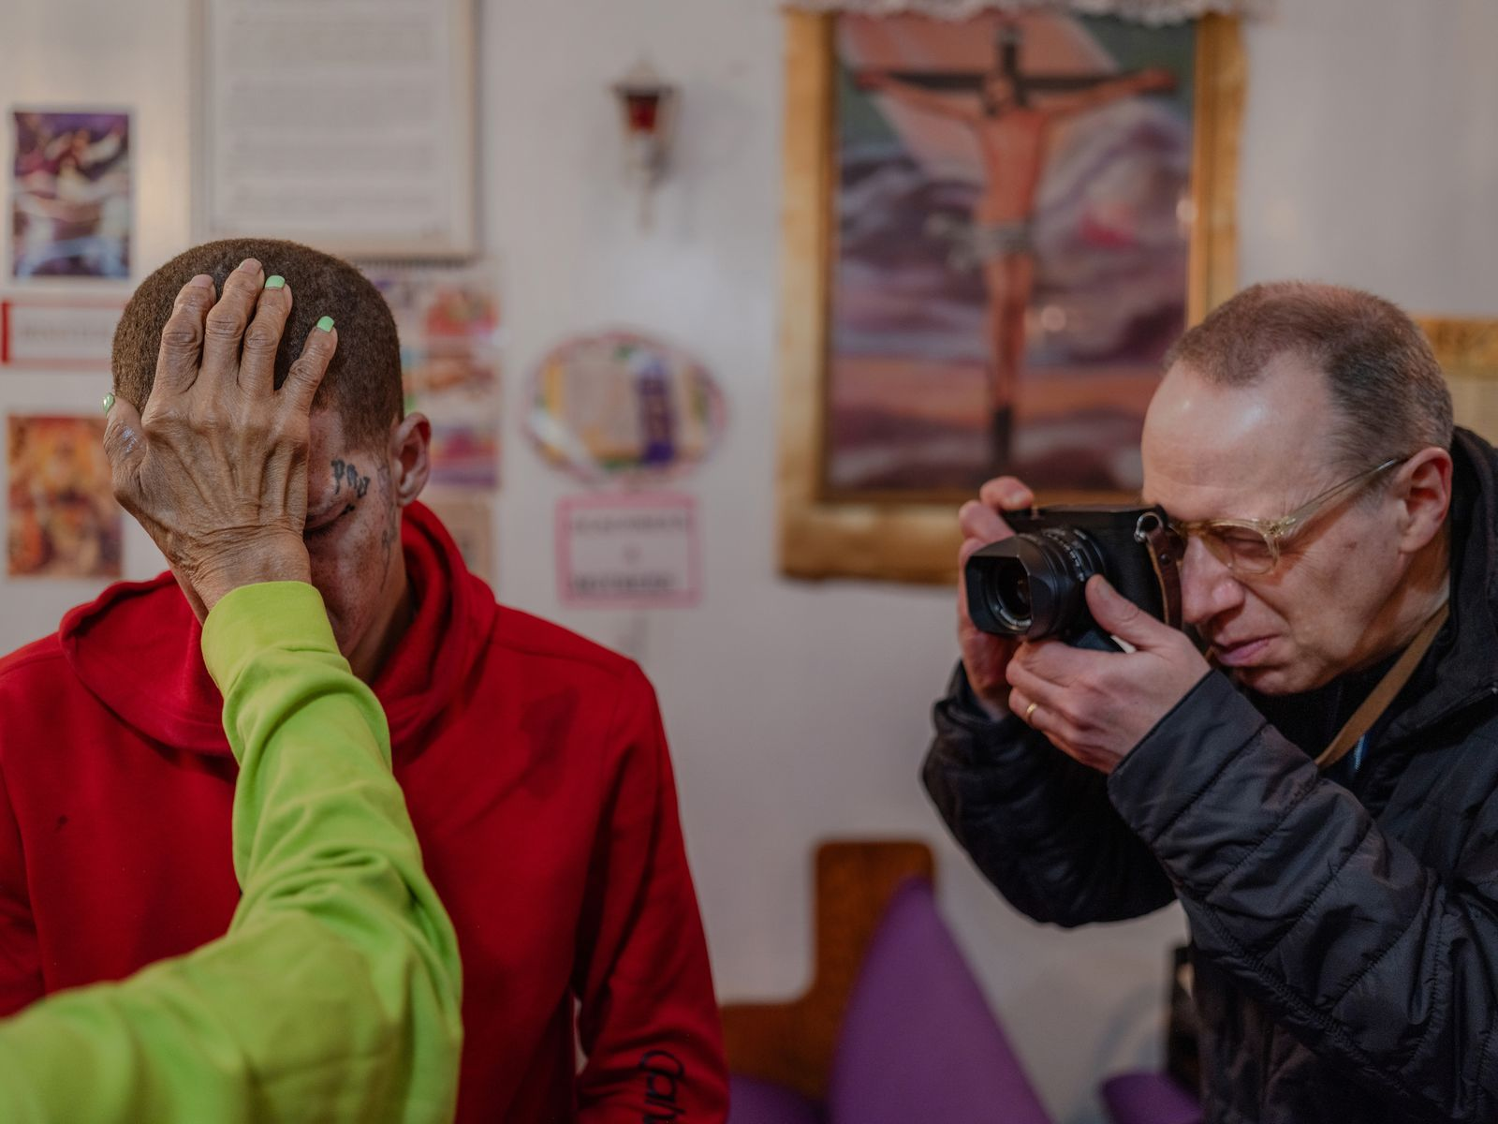

The Reverend Dr. Tinnie James, a pastor from the South Bronx, says a prayer for Red, and Gulbransen takes a photograph.

Sensing the mood, Gulbransen tried to lighten it. He listed people his patients ask about: nurses and doctors who’d once worked in his office. “Do you know who the most requested person is?” He paused. “It’s Red!” Red laughed. “I told them, ‘On Sunday morning, I’m getting Red and we’re going into rehab.’ So—are we doing it?”

Advertisement

“Yeah, we are,” Red said, with resolve. “Let’s get it done.”

He took a deep breath, stood, and started stuffing more belongings into his bag. Encouraged, Gulbransen stepped into the hallway to call the elevator.

“You know that guy who walked a tightrope between the Twin Towers?” he whispered as we waited. He meant [Philippe Petit](https://www.newyorker.com/magazine/1987/06/15/philippe-petit-profile-high-wire-artist), who pulled off the feat in 1974. “I’m like him, except I almost never make it to the second tower.” Red had already been to rehab seven times. “You just have to keep trying, trying, trying.”

Downstairs, the three of us crossed the street for coffee. We passed Red’s tag everywhere—a little crown with his name beneath it, drawn on walls, doorframes, intercom boxes. Then we went to find Veronica. In a nearby building, we checked the apartment where she and her boyfriend, Boogie, rented the kitchen as a bedroom. She wasn’t there. Boogie, a petty thief surrounded by piles of loot, pointed us toward a set of stairwells back in Red’s building.

“I’ll check the roof, too,” Red said. He’d grown bright-eyed, energetic—a member of G.’s team. He began working his way up and down the steps, whistling a little motif—a warble, then a pop—to announce himself to anyone he might surprise in the stairwell. No luck. “We gotta go,” Gulbransen said. “She’s not coming. It’s just you, Red.” He wanted to keep the momentum up. We made our way out and started walking briskly to the car.

“I bet she scored and decided she could make it a few more weeks without getting clean,” Red mused. “You know what’s crazy? I can’t decide whether, when she made that choice, it was a moment of weakness or strength.”

I glanced at Gulbransen. He looked worried, his jaw tight. I’d noticed that, when things got tough, his joviality faded and something steelier took over. Once, remembering his fights with opponents of the back-up-camera law, he’d told me, “I hate losing. I don’t lose. My attitude is ‘Fuck you.’ ” Another time, he described a dark moment after the accident: “It got back to me that someone I respect—a doctor—said to a friend, ‘God, how come Greg hasn’t killed himself yet?’ So, yeah, I knew everyone was watching me. I was the most watched person ever—a pediatrician who backed over his own kid.” He’d wanted to show what he was made of.

He always seemed aware of an audience—his peers, or maybe Cameron up above, or Leslie, Julia, and Scott, or simply everyone—observing, judging, learning. “I think, after Cameron, it was almost as if he needed to prove himself,” Leslie told me. “Maybe he didn’t feel like he was a good father, or a good doctor, or a good person, which . . .” She trailed off, incredulous. “It was an accident!” Regardless, Gulbransen said, “You have a responsibility to provide yourself as an example. There are a lot of people who lose kids, and you want to show them that, as horrible as this is, you’re going to be O.K.” Later, he said, “I wanted to show Scott and Julia how, when the shit hits the fan, you behave like *this*.”

In the car, Red nestled in the back, looking out the window, seemingly all right. But, as we were about to get on the highway, he said he’d left something valuable in the stairwell and needed to go get it.

“O.K., buddy,” Gulbransen said, turning the car around. Out on the sidewalk, as Red led us inside, Gulbransen fell in beside me.

“I think the percentage chance of this working out is dropping,” he murmured.

At the top of the stairs, Red bent to gather books and art supplies: “I collect a lot of random books, so I can use them for reference images”—sources for tattoo designs. He looked unwell. A long-legged cockroach crawled out from under an old sweatshirt and along the wall.

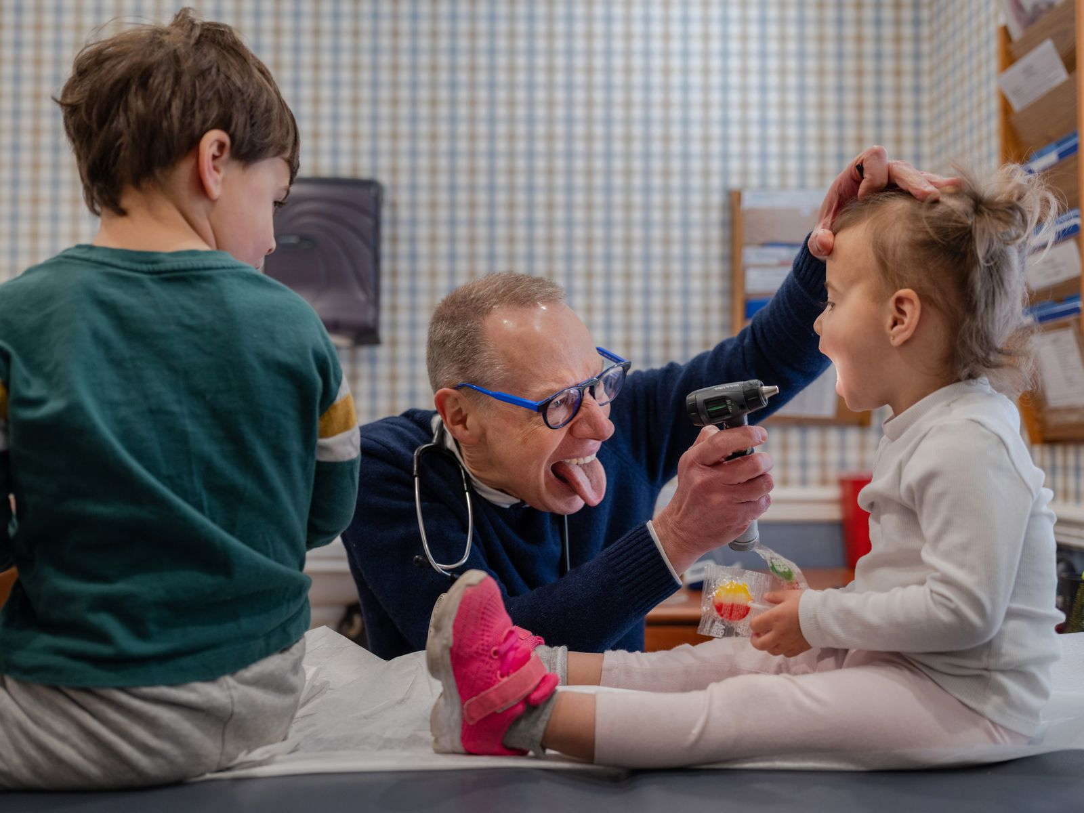

Gulbransen’s office has a relaxed, even buoyant, vibe. Photo collages in the waiting room show hundreds of patients, from infants to young adults.

“Dope-sick,” Gulbransen mouthed to me, grimly. Then he called up to Red, “Let’s get organized! Let’s go!”

Red sat down. I looked again: now he had a syringe in his hand. We watched as he searched for a vein, fruitlessly. Eventually, he settled on a spot on his neck. “Aghhh,” he said, grimacing and pushing the plunger. He leaned back. Gulbransen sank to his haunches and breathed in and out. For the first time, he looked drawn, sad, exhausted. Red started singing, wordlessly at first. Then he stood up, almost vibrating with energy. “I would do anything for love!” he sang.

Advertisement

“It’s not gonna work,” Gulbransen muttered to himself.

Red drifted into Kendrick Lamar: “I got power, poison, pain, and joy inside my DNA,” he rapped, then moved on, folding in other songs, bits of pop refrains. When he sings, Red often chooses lyrics that describe his situation. Gulbransen slumped forward, cradled his head in his hands, and listened. We lingered—twenty minutes, then thirty—hoping for some reversal, until it became clear it wasn’t coming. We left.

Later, at home, playing with my kids, I kept thinking about Red, and about Gulbransen, hunched at the bottom of those stairs. I found myself returning to that image as the days went by. How many mornings had he spent like that—alone, in ruined stairwells, hallways, elevators, apartments? I pictured him there, on his own, unobserved, trying to help. That set of stairs was one of the worst places I’d ever been. The next Saturday morning, I again thought of Gulbransen. Where was he now?

Around eleven, Gulbransen texted me a screenshot of a message from Red: “Hello Sir. First I want to apologize . . . I was wrong. I’m sorry for wasting your time and disappointing you. I really had every intention of going to detox that day. It’s red btw. This is my new number.”

Gulbransen had replied, “Don’t apologize. Fentanyl is the devil pulling you down hard. If you want to retry again tomorrow morning, LMK. I’m always here for you. G.”

A few weeks passed. Red’s life resumed its usual pattern. Then, one Sunday, Gulbransen went looking for Red and couldn’t find him. He searched every hideout—nothing. He grew alarmed. Had the worst happened? He was back at his office, seeing patients, when he got a voice mail: “Hey, G., it’s Red. Just wanted to tell you, I’m calling from rehab. I finally made it—I’ve landed. I am currently clean. I just wanted you to know where I was. I’ll call back again to try to get in touch with you. I just didn’t want you to worry.”

In the afternoon, I FaceTimed Gulbransen. He looked relieved. “I like that he loves to make me proud of him,” Gulbransen said. That weekend, he was leaving for a short vacation with his wife and daughter—his first in two years. But he’d found some helpers in the projects who’d send him news about Red while he was gone.

“I’ll stay in touch and keep you updated,” he told me, beaming. He ended our exchange the way he often does: “Hug the kids.” ♦

Published in the print edition of the [July 21, 2025](https://www.newyorker.com/magazine/2025/07/21), issue, with the headline “Family Practice.”