[Letter from Gaza](https://www.newyorker.com/magazine/letter-from-gaza)

Hospitals in Ruins

Hospitals in Ruins

*Doctors are delivering lifesaving care in a ravaged health-care system—and risking their own lives in the process.*

**By**[**Clayton Dalton**](https://www.newyorker.com/contributors/clayton-dalton)

April 18, 2025

The view from the destroyed emergency department at Al-Shifa Hospital, in northern Gaza.Photographs and videos by the author

On January 29th, two weeks after Israel and Hamas agreed to a ceasefire, I crossed into Gaza as part of a twelve-person medical mission. After traversing southern Israel in a U.N. convoy, we followed an Israeli military escort through a maze of concrete barriers. Then we got out of our vehicles and lugged suitcases full of essentials—gauze, antibiotics, catheters, trauma shears—through a metal blast door. We passed a no man’s land of razor wire where, improbably, dandelions grew. Finally, we climbed into a van with a shattered windshield and drove to Khan Younis, a city of several hundred thousand in southern Gaza. Our driver swerved to avoid craters; almost every structure we passed was damaged. At one intersection, a minaret stood over a ruined mosque. Still, the city was alive. I saw a family drinking tea in a building with no roof. Laundry fluttered from balconies, and lettuce grew in the courtyard of a destroyed building. Nearly half of Gaza’s two million residents are children, and they were everywhere—laughing, waving, flying paper kites.

When I first signed up to work in Gaza, in late 2024, the Israeli military was carrying out more or less daily ground and air offensives. Wounded patients were overwhelming the region’s barely functioning health-care system. I was expecting to hunker down in a single hospital and spend two weeks helping to treat them. Instead, when I arrived, Israeli forces had withdrawn from parts of Gaza, air strikes had largely stopped, and displaced families were returning to places they had fled. This meant that our view was not limited to the inside of one building. I would get an unusually complete picture of the state of Gaza’s medical infrastructure.

We spent the night at Nasser Hospital, a five-story beige-and-brown building in Khan Younis. As we drove up to it, a bystander, recognizing us as aid workers, shouted a plea through the window of our van: “Stay with us! Don’t just come and leave. Humanity is happening here!” Nasser had been the site of a major attack in February, 2024, when the Israeli military—the I.D.F.—shelled the hospital, cut off its power and oxygen, and raided the building. A doctor told CNN that he was strip-searched. “We are completely besieged,” he said. “We have been without electricity, oxygen, heating, barely any food or water.” Gaza’s health ministry reported that a dozen patients died as a result of the attack; the World Health Organization warned that “further disruption to lifesaving care for the sick and injured would lead to more deaths.”

The I.D.F. told a different story. It said that at Nasser it had found weapons, in addition to medicines meant for Israeli hostages. It also claimed that it had apprehended hundreds of suspected terrorists, including some who had allegedly posed or worked as medical staff. “The operational activity was conducted to ensure minimal disruption to the hospital’s ongoing activities and without harming patients and medical staff,” an I.D.F. statement said. “The IDF will continue to operate in accordance with international law against the Hamas terrorist organization, which systematically operates from hospitals.” At Gaza’s thirty-six hospitals, this dynamic has played out again and again. The I.D.F. has justified the bombing and raiding of hospitals, potential war crimes, by accusing Hamas of war crimes: turning medical centers into “terror hubs” and hiding behind civilian infrastructure. But Israeli officials rarely provide enough evidence for news outlets and international organizations to verify their claims. Hamas has denied using health-care facilities for military purposes.

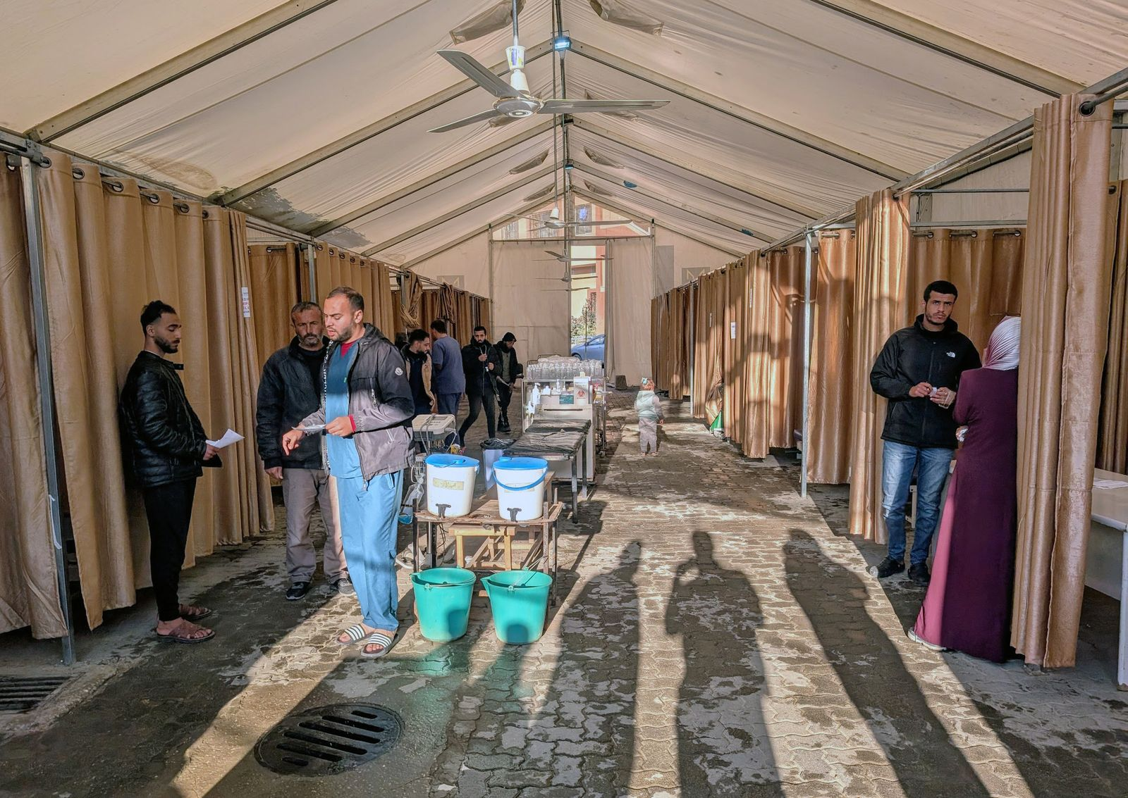

Medical personnel work in a makeshift tent outside Nasser Hospital.

Nasser had been largely repaired, but reminders of the violence were everywhere. In an adjacent field lay the twisted and charred remains of ambulances. On a balcony outside our sleeping quarters, a Palestinian doctor showed us bullet holes from sniper fire that he said had been aimed at him and his colleagues. A surgeon on our team said that, during a previous mission, he had found a human finger bone on the hospital grounds; not knowing what else to do, he buried it.

The next day, several of us were driven to Al-Aqsa Martyrs Hospital, ten kilometres away, in central Gaza. Going north, we saw whole blocks of levelled buildings. Hundreds of informal shelters—cobbled together from sheet metal, car doors, carpets, tarps—had been erected amid slabs of concrete. People were sorting debris into piles; we passed a man sweeping the street with a broom.

Al-Aqsa, a cluster of shrapnel-scarred yellow brick buildings in a dense residential neighborhood, was originally built to accommodate a few hundred patients. Then air strikes, an I.D.F. ground invasion, and heavy fighting with Palestinian militants drove nearly a million people into the area. The facility sometimes received more than a thousand patients a day, and frequently ran out of fuel and supplies. Al-Aqsa also became a target. Air strikes hit a courtyard where thousands of people were sheltering in tents. The I.D.F. said the hospital was housing a terrorist command center.

Our guide at Al-Aqsa was a burly thirty-five-year-old orthopedics resident named Mohammad Shaheen. He joked that the conflict had been great for his figure—he’d lost thirty kilos. He slid open the door of a cavernous metal shed that had served as a makeshift ward. “We built it in ten days,” he said. Now it was dark, with empty stretchers in the corners. “We are turning from trauma to reconstruction,” he told me. Countless Gazans needed medical care for past injuries and untreated medical conditions. Entire neighborhoods had to be cleared of rubble and unexploded ordnance.

The Al-Aqsa emergency department was a dimly lit space that contained about fifteen beds. To my surprise, only one held a patient. My specialty, emergency medicine, had apparently not been in high demand here since the start of the ceasefire. Al-Aqsa’s director suggested that, instead of staffing an eerily calm E.R., perhaps I should document the state of hospitals across Gaza. “We deserve a better life than this,” he said.

That afternoon, in the operating room, I saw a young man whose left hand had been mangled. A surgeon scrubbed his hands while telling me what had happened: the man had returned to the wreckage of his home and a bomb had exploded. There were no tourniquets available, so a bladder catheter had been tied around his arm to slow the bleeding. There were no hospital gowns, either, so he was wearing a red turtleneck when an anesthesiologist put him under.

Upstairs was the intensive-care unit. On its door, which was locked, someone had written “ICU” in red marker. A man in the hallway outside jimmied the door open with a spoon. Inside, one of my colleagues, a bearded intensivist named Shiraz Saleem, was treating a teen-age girl with diabetic ketoacidosis, a life-threatening complication of diabetes caused by a lack of insulin. But her doctors were having trouble monitoring her blood sugar because they didn’t have a glucometer, a device that American pharmacies sell for about twenty dollars.

In the pediatrics ward, a cramped space that had cartoon characters painted on the walls, a nine-year-old named Mariam cried softly as another of my colleagues examined her. Her hair was neatly braided and tied with a yellow scrunchie. Mariam had lost an arm to amputation after an air strike, and shrapnel had slashed a hole between her bladder and her rectum. She had already undergone five surgeries. On a bed next to her lay a three-year-old boy, who had needed surgery after he was injured in an air strike; his five-year-old brother was killed in the attack. The boy was suffering from an infected surgical wound. “It just doesn’t feel real,” Saleem told me later. “How can something so horrible be real?”

Advertisement

In the evening, a Palestinian urologist showed me photographs on his phone of patients he had treated. I saw a young man who had reportedly been shot in the groin by an Israeli sniper, a thirty-five-year-old woman with a blast injury to the vagina, a man whose scrotum had been blown apart. The urologist’s face, lit by the glow of these images, was ashen. He kept scrolling, deeper into the past, until his camera roll suddenly entered a different reality—photographs of family gatherings, children running in the grass.

On October 7, 2023, thousands of militants led by Hamas crossed into Israel and carried out numerous carefully planned attacks on civilians, many of whom were attending a music festival. Gunmen on motorcycles and in pickup trucks surrounded fleeing people and opened fire. In nearby kibbutzim, they went house to house, shooting some residents and kidnapping others. About twelve hundred people were killed, including several dozen children, and more than two hundred and fifty people, ranging in age from nine months to eighty-five years old, were taken hostage. (Fifty-nine hostages remain in Gaza; twenty-four are believed to be alive.) Israel and the rest of the world were flooded with images of the bloody aftermath; some showed bodies burned beyond recognition. By the end of the day, Israeli leaders were talking not only about justice but also about retribution. “We will take mighty vengeance for this black day,” Prime Minister Benjamin Netanyahu declared. “All the places where Hamas hides, operates from—we will turn them into cities of ruins.”

Israeli forces have now dropped more explosives in Gaza than fell on London, Dresden, and Hamburg combined during the Second World War. More than fifty thousand Palestinians have been killed. Hospitals have not been spared; most are no longer functional. A few weeks before my trip, the World Health Organization reported that more than a thousand health-care workers had been killed, and that it had verified six hundred and fifty-four strikes on Gaza’s medical facilities. The territory’s health sector was “being systematically dismantled,” a W.H.O. representative said. Just last month, Israeli soldiers were filmed opening fire on ambulances in southern Gaza, killing fifteen rescue workers. An I.D.F. spokesperson initially claimed that the vehicles were “advancing suspiciously toward IDF troops without headlights or emergency signals,” but the I.D.F. walked back that statement and opened an inquiry after footage published by the *Times* showed a uniformed medic next to motionless and clearly marked ambulances, followed by five minutes of gunfire from the I.D.F.

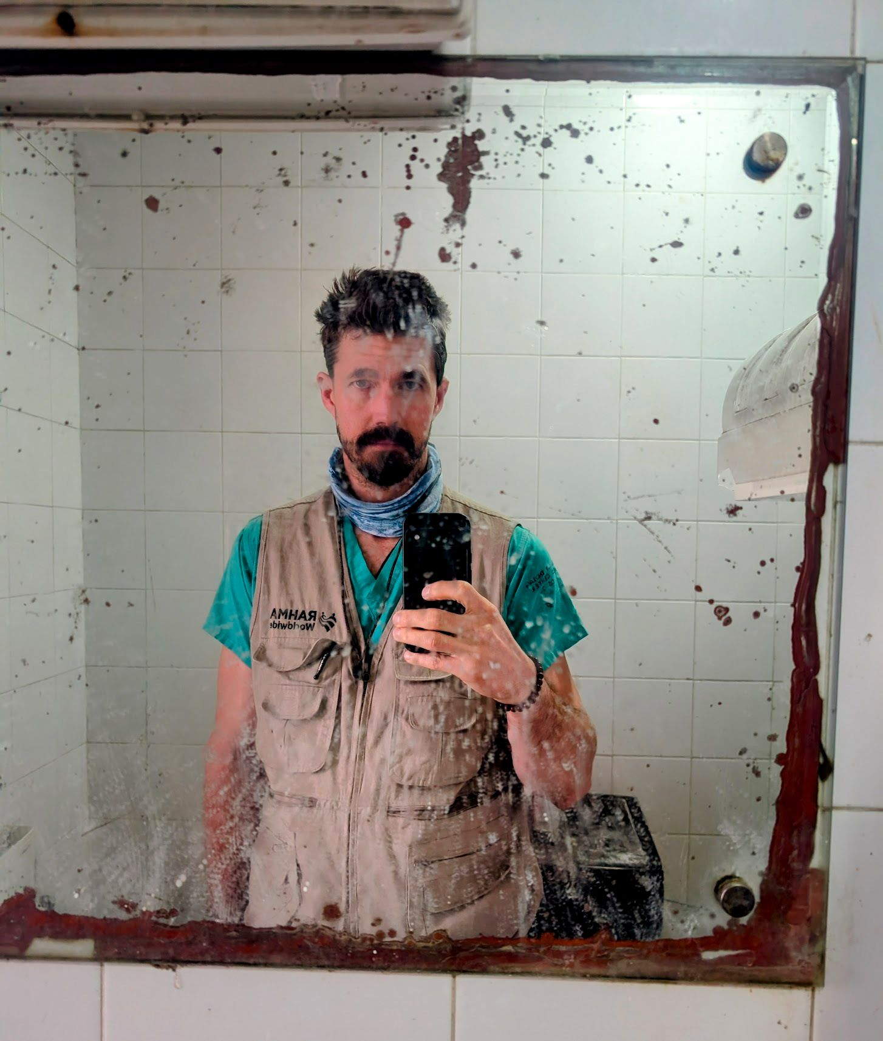

The author in Al-Aqsa Hospital, in central Gaza. The ceasefire between Israel and Hamas offered an unprecedented window into devastated medical facilities.

Since October 7th, reporting from inside Gaza has been extremely limited. According to the Committee to Protect Journalists, at least a hundred and sixty-nine media workers have been killed in Israel and the occupied Palestinian territories—one of them in a media tent outside Al-Aqsa Hospital, last year, and another near Nasser Hospital, earlier this month. While I was there, the simple fact that I could leave the hospital felt surreal.

One evening, I took a walk with Saleem, Shaheen, and a twenty-two-year-old medical student. We passed venders selling mismatched shoes and recently arrived produce. I saw a man in a barber’s chair, getting his hair trimmed. A few bursts of automatic gunfire echoed in the distance—gangs, I was told. I heard birdsong and looked around; three metal cages were tied to the side of a tent, each with a small pet bird inside. Then we came to a deserted school that had been used as a shelter. A group of children emerged from the shadows. “How do you do!” a boy called out. The children led us up to the roof and pointed down at a field of newly planted olive trees—a beautiful, hopeful sight. Before Saleem and I left the school, the boy, whose name was Ali, ran up to us, looped his arms through each of ours, and swung his blackened feet as though they were a pendulum. His laughter rang through the school.

The next morning, the medical student took me to an ambulance station next to Al-Aqsa. Every ambulance showed signs of damage. A sixty-year-old paramedic told me that after a building was bombed drones often circled, and rescuers were afraid to enter until the drones left. I asked the paramedics what was hardest about this work. Responding to an air strike and discovering that it’s your own family, one said. Recovering the bodies of children, another said. He paused, then added, “It is strange that the world has allowed this to happen to us.”

The medical student also brought me to the orthopedics department. “Explosive injuries are contaminated,” an orthopedist explained, lighting a cigarette. “We do damage control.” You couldn’t repair bones with plates and screws, he said, because the wound would get infected. Instead, in a process called external fixation, doctors pushed metal pins through the skin and into the bone; the pins were attached to a scaffold outside the body. The resulting infection rate was still as high as eighty per cent. Because the hospital lacked saline to irrigate wounds, doctors mixed tap water with chlorine meant for swimming pools.

That day, a young man was having an operation in what had once been an exam room. A surgeon said that a drone had shot him in the thigh, splintering his femur. External fixation had stabilized the fracture, but the bone had become uncontrollably infected. The surgeon swatted away a fly, then held the wound open to show me the bone’s sharp, broken ends. He was planning an extreme form of amputation called hip disarticulation; if the patient survived, he was unlikely to walk again.

An estimated twenty-six thousand people have undergone external fixation in Gaza, and many will wait years for follow-up surgery. “It will be a miserable life for them,” the orthopedist said. He showed me a photograph of a patient’s mutilated feet, which had required amputation. Then he swiped to a photo of a silver missile sticking out of the ground in front of his home. “GBU-39” was stencilled on its side. Later, I looked it up. It was a two-hundred-and-fifty-pound guided American munition, manufactured by Boeing.

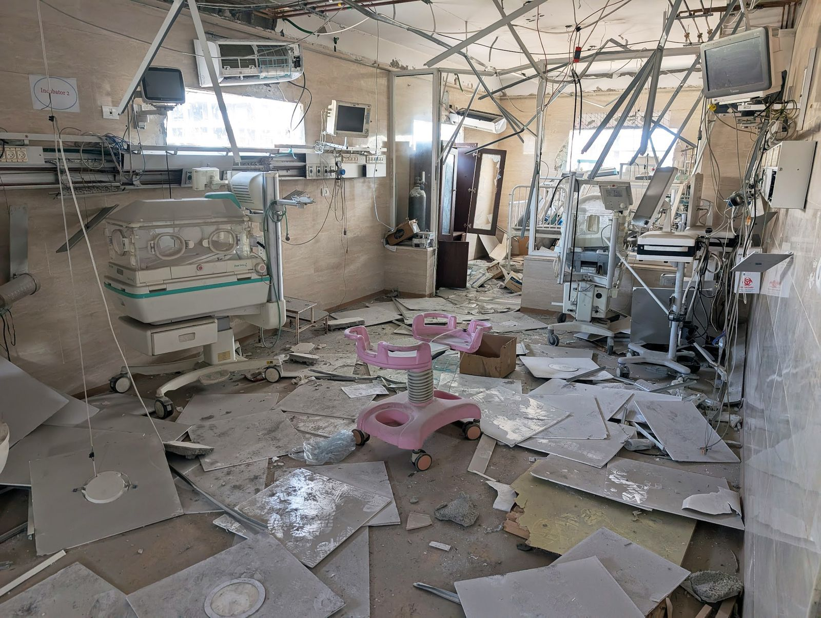

A badly damaged neonatal intensive-care unit at Kamal Adwan Hospital.

The worst devastation was in northern Gaza, which looked in some photographs like Hiroshima after the atomic bomb. Most of the twenty-two hospitals in the north had come under direct attack, according to CNN. I kept hearing that Al-Shifa, the primary teaching and referral hospital in Gaza, had been completely destroyed. On the morning of my fifth day, I set out on foot with Ahmed Alassouli, one of the coördinators of the medical mission, on the Al-Rashid road, which runs along the Mediterranean. We hoped to visit the most important hospitals in the north, something that hardly any outsiders had managed since October 7th; the I.D.F. had not permitted foreign journalists to visit without an escort, and medical workers often stayed in a single hospital, for safety reasons. To our left, we could see glittering waves and fishermen tending to nets. To our right was a wasteland. Black smoke rose in the distance, and a white flag licked the wind on the roof of a bombed-out building.

After we had walked for a few hours, Alassouli was able to hail a car, and we clambered into a metal trailer hitched to the back. A man riding next to me opened a package of crackers and offered me one. On the outskirts of Gaza City, we climbed into a battered S.U.V. I saw a woman dump a bucket of dust out an open window; a man smoked inside an apartment that was missing a wall.

The emergency department of Kamal Adwan Hospital, north of Gaza City, was unrecognizable as a health-care facility. We were accompanied by Ezz, a slight twenty-three-year-old medical student with dark, wavy hair, who would be our interpreter in the north. The I.D.F. has alleged that Kamal Adwan was a military command center for Hamas. During an I.D.F. raid in December, the hospital was ravaged by a fire; I could see where smoke had poured out of broken windows, staining the exterior black. I put on a surgical mask and followed a surgeon named Sakher Hamad inside. A noxious odor permeated the space, and smashed glass vials crunched beneath our feet. We used our cellphones to light the way. Ezz pointed out a room where he had taken a standardized clinical exam during the conflict. It now contained only blackened bed frames. Hamad led me upstairs, to the maternity wards. They had also burned. In the neonatal I.C.U., which had been the last such unit in northern Gaza, destroyed incubators were strewn across the floor. After raiding the I.C.U., Israel had released a video of what it said were weapons found in an incubator.

In another wing, Hamad showed us three charred operating rooms. A beam of daylight slashed down through a crack in the ceiling. The dialysis wing, also ruined, was down the hall. We exited the hospital through what had once been the main entrance but was now a hole in a blackened, crumbling façade. In front of the hospital was a mass grave, Hamad told me. I asked how many people were buried there.“We don’t know,” he said.

A charred operating room at Kamal Adwan Hospital.

Advertisement

Ezz’s house had been destroyed on the second day of the war. He took up residence as a volunteer at Al-Shifa Hospital—the largest medical facility in Gaza, with seven hundred beds and twenty-five operating rooms. Then the I.D.F. said intelligence suggested that there was a Hamas command center in tunnels underneath the facility. In November, 2023, the I.D.F. began a siege that culminated in a raid; the hospital was incapacitated. Later, the I.D.F. released photographs of tunnels and weapons that it said were found there.

Ezz told me that during the raid doctors had to perform thoracostomies, in which the chest is cut open to relieve pressure from internal injuries, without pain medication or sedatives. “The screaming of the patients was very loud,” he said. They had no CT scanner or neurosurgeon; patients with severe head trauma eventually stopped breathing and died. Even after these experiences, Ezz seemed intent on practicing medicine in Gaza, perhaps after a residency abroad. “This is my purpose,” he said.

Motaz Harara, the director of Al-Shifa’s emergency department, met us at a former outpatient clinic near the main hospital, which he had filled with twenty-eight beds and turned into a small E.R. After air strikes, Harara said, the makeshift space sometimes received three or four hundred patients. The rest of Al-Shifa, however, was abandoned. What had once been an airy hospital atrium was now a tangle of rebar and pulverized concrete. On one side of the space, an elevator shaft and part of a staircase had fallen into the basement. The rest of the staircase dangled from the ceiling. We carefully made our way past burned stretchers and equipment carts to the rear half of the ground floor, which had been the emergency department.

The E.R. was vast, largely empty, and black with soot. Several pillars were all that was left of the rear wall. Through the spaces between them, I could see a large graveyard behind the hospital, where rubble had been repurposed as headstones. When I asked Harara if any part of the hospital could be repaired, he shook his head. An official with Medical Aid for Palestinians, a U.K.-based charity, has said that its reconstruction could take more than twenty years.

Since 1950, Israel has been a signatory to the Geneva Conventions, which state that civilian hospitals “may in no circumstances be the object of attack, but shall at all times be respected and protected.” A 1977 amendment prohibits any attack “which may be expected to cause incidental loss of civilian life, injury to civilians, damage to civilian objects, or a combination thereof, which would be excessive in relation to the concrete and direct military advantage anticipated.” Since October 7th, Israel has publicly pledged to spare nonmilitary infrastructure and personnel. “We will do our best not to harm innocents,” Israel’s Ambassador to the European Union said in November, 2023. “We are bound to the international law.” A hospital retains its special status even if it is treating wounded combatants, but if it is used for an “act harmful to the enemy,” such as hiding soldiers or storing weapons—a violation of international law—it loses humanitarian protections. (Even then, civilian medical staff and patients are legally protected.)

Last fall, a team of Harvard researchers published an analysis of the distance between Gaza’s hospitals and the craters from two-thousand-pound M-84 bombs. An M-84 can displace more than five tons of dirt and create shock waves strong enough to burst lungs and sinuses. “It pancakes entire buildings,” a former Pentagon official has said. The paper noted that, during the first six weeks of the conflict, eighty-four per cent of Gaza’s hospitals were within the damage range of at least one such crater, and a quarter were within the lethal range. “I don’t see any evidence that they tried to protect civilians or civilian infrastructure,” one of the authors, a spatial epidemiologist and emergency physician named P. Gregg Greenough, told me. “How could you be using these kinds of weapons, in this kind of setting, and still argue that you are adhering to international humanitarian law?” The I.D.F. told *The New Yorker* that it “does not intentionally target uninvolved civilians.” It said that it “recognizes the special protections granted to medical teams under international humanitarian law and is committed to taking all necessary measures to mitigate harm to them and minimize the disruption to medical services.”

A makeshift graveyard is visible from Al-Shifa Hospital.

When we walked through the gate of Al-Ahli Arab Hospital—the closest thing to a functional hospital left in the north—we saw two tan-colored buildings and a modern-looking tower topped with solar panels. Most of its windows were jagged with glass shards. Al-Ahli was founded in 1882 by Anglican missionaries. A plaque commemorated a 2011 renovation sponsored by U.S.A.I.D. Mule wagons were constantly dropping off new patients, many of whom had external-fixation pins protruding from their arms or legs. A chapel, riddled with shrapnel damage, had been turned into a medical ward. Ezz led us to a small E.R. that, despite the ceasefire, was at capacity. There were no ventilators, defibrillators, or I.V. pumps. I counted two cardiac monitors and eighteen cots. “Two monitors for half a million people,” Ezz said. “Unbelievable.”

Ezz introduced me to Fadil Naim, who directs the facility. The hospital had space for about fifty inpatients but routinely cared for hundreds, so some slept outside. Naim was the only senior orthopedic surgeon in the hospital, but he’d gotten help by training whomever he could. “I have a third-year medical student that can now do orthopedic surgery,” he said.

Early in the conflict, Naim called Ezz with terrible news. Ezz’s mother had arrived in the Al-Ahli emergency room. His grandparents’ house had been bombed. After rescuers arrived, a second bomb exploded nearby, Ezz said. His mother survived, but twenty of his family members, including his father, brother, grandmother, niece, and sister-in-law, were killed. “Some of them are still buried under the rubble,” Ezz told me.

Many of the houses in Beit Lahia, in the northernmost part of Gaza, were not simply damaged but flattened. The Indonesian Hospital, a stately four-story building, was one of the few structures in the vicinity still standing, though it, too, had reportedly been shelled. Sparrows darted from one pile of rubble to another; I heard what was probably an unexploded bomb detonate in the distance. Marwan Sultan, a cardiologist and the director of the hospital, led us through darkened hallways, his white coat billowing behind him.

[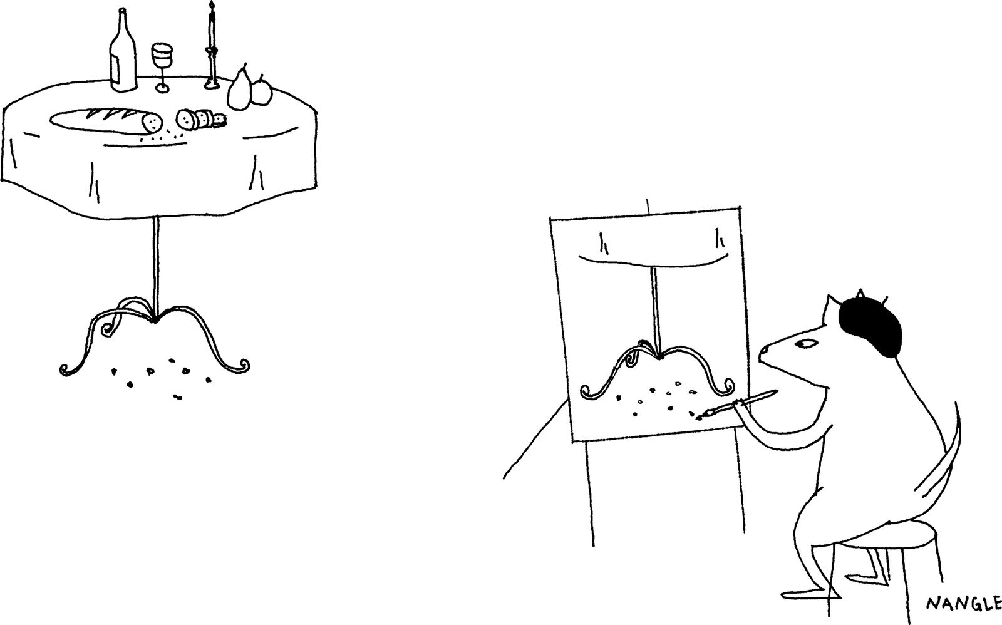](https://www.newyorker.com/cartoon/a61034)

Cartoon by Jared Nangle

Copy link to cartoon

Link copied

Shop

Open cartoon gallery

Only the E.R. remained operational. Doctors had performed neurosurgery in a dental chair and amputations on the ground, Sultan said. Outside, he showed me the wreckage of several generators and an oxygen station. Israeli forces “destroyed the lungs of the hospital,” he said. I saw a hole in the side of the building where he said a tank had driven through the wall. In the hospital courtyard, there were grave markers made from ceiling tiles. An I.D.F. spokesperson said that weapons and tunnels were found at the facility.

Sultan led me upstairs, to the I.C.U., where wind blew through broken windows. He wanted to show me something that he had discovered after Israeli forces left the hospital. He pointed to a cardiac monitor near a wall. It appeared to have a bullet hole in its screen. Next to it was an EKG machine whose screen had been smashed.

We entered a large storage room in the corner of the I.C.U. which was crammed with medical devices: ultrasound machines, I.V. pumps, dialysis machines, blood-pressure monitors. Each had apparently been destroyed by a bullet—not in a pattern one would expect from random shooting but, rather, methodically. I was stunned. I couldn’t think of any possible military justification for destroying lifesaving equipment. When I asked the I.D.F. for comment, the spokesperson said, “Claims that the IDF deliberately targets medical equipment are unequivocally false.”

The ceasefire in Gaza ultimately lasted just two months. In February, I flew back to the U.S. On March 2nd, Israel blocked all humanitarian aid, including medical supplies, from entering Gaza, in an effort to pressure Hamas into accepting revised ceasefire terms. On the night of March 18th, it resumed its bombing campaign. By morning, more than four hundred people had been killed, according to Gaza’s health ministry. The hospitals in the north soon had too many patients and too few supplies to treat them, Ezz told me in a text. “Every day we face impossible choices,” he wrote. This past week, the I.D.F. warned Al-Ahli’s medical staff to evacuate patients; twenty minutes later, missiles disabled the emergency department and destroyed a genetics laboratory. The I.D.F. said that Hamas was operating there, which the group denied.

When bombs began falling in Khan Younis, Feroze Sidhwa, an American trauma surgeon who had been to Gaza before, was in Nasser Hospital, sleeping in the same room where I had stayed. I knew him from a group chat of health-care workers who had gone on medical missions like mine. Sidhwa, a stoic man with short hair, woke up when the pressure wave from an explosion blew the door open. He rushed to the E.R.

In the hours that followed, two hundred and twenty-one people were brought to the hospital. Ninety-two were soon pronounced dead. Sidhwa searched for patients who needed emergency surgery. “It was chaos,” he said. “The rooms were full of kids dying on the floor, bleeding, screaming, crying.” Some patients were alive but beyond saving with the hospital’s limited resources. Sidhwa saw several children with severe brain injuries. The hospital had no neurosurgeon, so there was little that could be done for them. After evaluating a young girl, he pointed her relative to a specific part of the E.R., where dying patients were sent. “Pick her up and take her over there, and just stay with her,” he remembers saying.

The next patient he evaluated was a five-year-old girl with shrapnel wounds to the chest, abdomen, and head. The E.R., which had been empty when I visited, in January, was so crowded with patients that he couldn’t push her gurney to the CT scanner. Instead, he picked her up and carried her. Her scans suggested that her brain injuries were survivable, so he carried her to the operating room and repaired her internal abdominal injuries. (Five days later, she would be talking again.)

Marwan Sultan, a cardiologist and the director of the Indonesian Hospital, points out medical devices that appear to have been shattered by bullets.

He proceeded to treat a tennis-ball-size hole in a woman’s back, another patient’s lacerated aorta, and a five-year-old boy whose entire body had been sprayed with shrapnel, causing cardiac arrest. One of Sidhwa’s colleagues opened the boy’s chest as though it were a clamshell and sewed up holes in the ventricles of his heart. The colleague re-started the boy’s heart by injecting epinephrine into it, and together they repaired damage to the boy’s liver, diaphragm, colon, stomach, and kidney. Despite their efforts, the boy died.

Sidhwa said that one of his last patients that night was a sixteen-year-old boy named Ibrahim, who had sustained intestinal injuries from shrapnel. Sidhwa stitched up the boy’s rectum and created an ostomy—a hole that exits the abdomen—to allow his digestive tract to heal. Ibrahim had black hair and looked thin from malnutrition. He was expected to make a full recovery. The boy’s father seemed to know only two words in English—“thank you”—and kept repeating them. “It was sweet,” Sidhwa told me.

Advertisement

Five days later, Ibrahim was almost ready to be sent home. That afternoon, Sidhwa was on his way to check on him when a colleague flagged him down. As they were discussing a patient, an explosion rocked the hospital. Sidhwa’s Palestinian colleagues pulled him away from the windows; the building had been hit. The I.D.F later said that the strike had targeted a senior Hamas political leader named Ismail Barhoum. A spokesperson alleged that Barhoum was “in the hospital to commit acts of terrorism.” Sidhwa called this claim “fucking ridiculous.” Barhoum was related to Ibrahim, Sidhwa told me, so they received medical treatment in the same room. “He was wounded and he was here as a patient,” he said. “I’m telling you this as an eyewitness.”

After the attack, Sidhwa again raced to the E.R. “We didn’t know if the Israelis were going to raid the hospital, or bomb it again,” he told me. Eventually, several men rushed in, carrying a teen-age boy in a bedsheet. They brought him into the trauma bay and set him down on a gurney. When Sidhwa drew the sheet back, he was shocked. The patient’s abdomen was shredded and his bowels were spilling out. It was Ibrahim, and he was dead. ♦

Published in the print edition of the [April 28, 2025](https://www.newyorker.com/magazine/2025/04/28), issue.