[Fiction](https://www.newyorker.com/magazine/fiction)

Natural History

By [Clare Sestanovich](https://www.newyorker.com/contributors/clare-sestanovich)

July 13, 2025

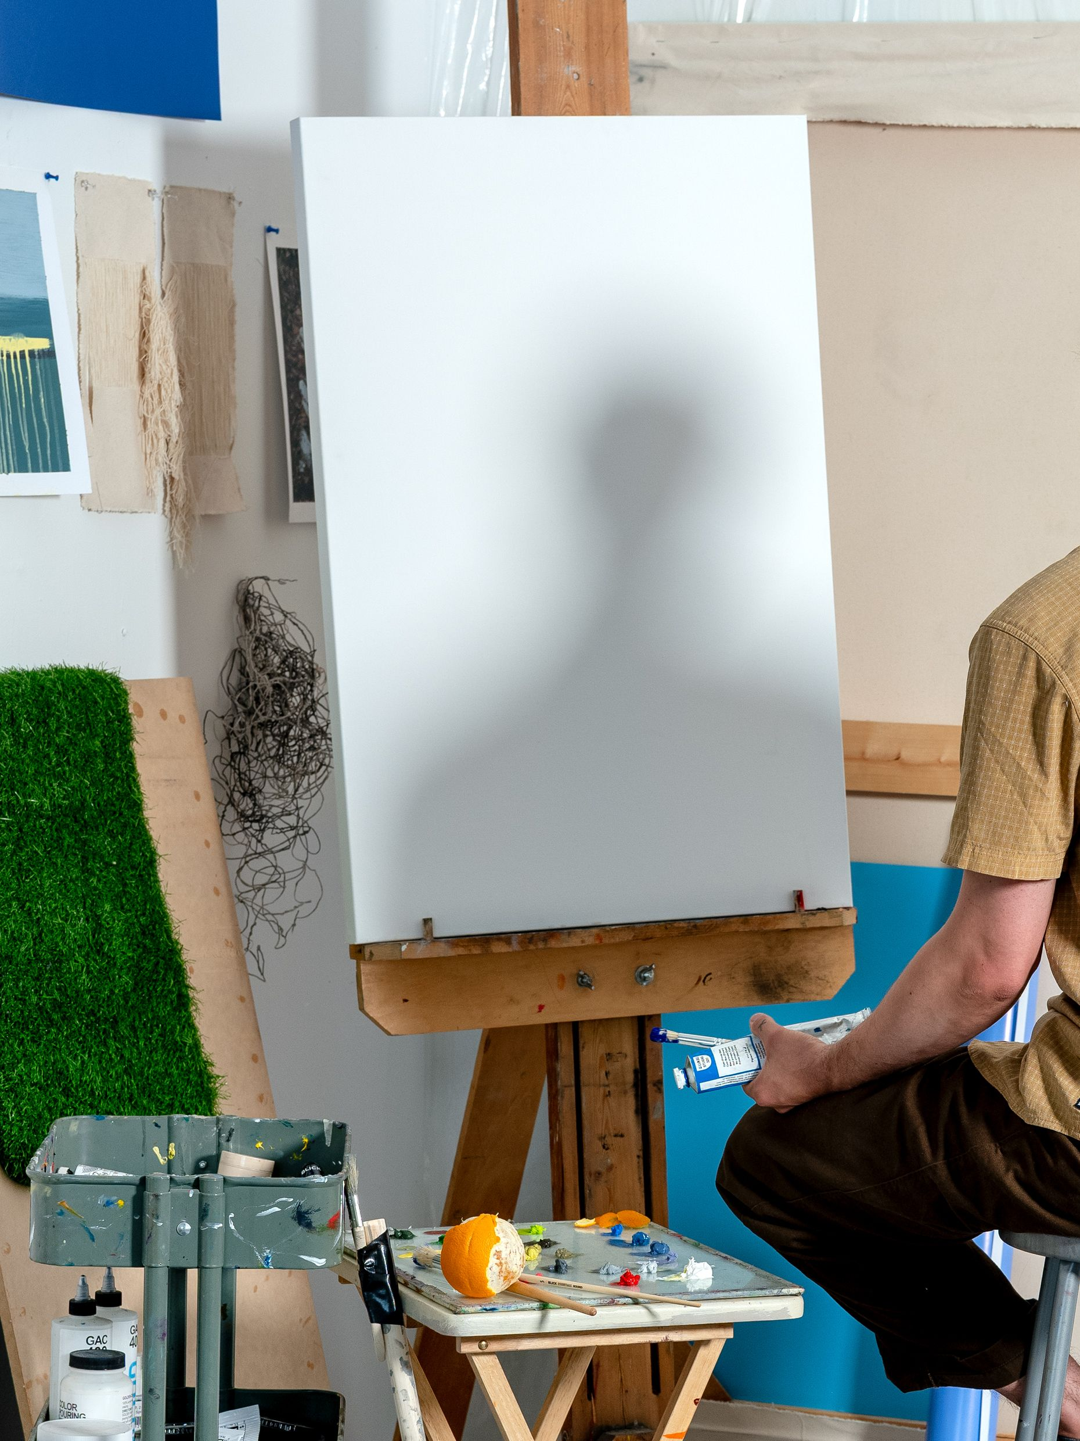

Photograph by Sarah Meftah for The New Yorker

He walked out of the precinct and wondered immediately what time it was. He didn’t have his phone, never wore a watch. It was dark when they took him in and dark when they let him out. Darkness in the city always contained its own confusion: you could never really escape the light, beams and squares and cones of it, white and orange and blue. Looking up, he tried to decide if the sky was a night sky or a morning sky. A before or an after. He thought, Is it still yesterday? A thought that didn’t make any sense. Yesterday, the most important day of his life. Unless it was today.

He paused for a moment at the threshold of inside and outside. He hadn’t really been inside, of course, not the way some people were: for months, for years, waiting for a trial, or a plea, or death. He faced a huge parking lot, lined with police cars and surrounded by an imposing fence. There were a few police buses, too, which looked like school buses except they were white instead of yellow and the windows were covered with metal grates. Some of the other protesters had been transported in these, but he had arrived on a city bus, commandeered by two irritated officers. It was less crowded than a regular city bus, and everyone got a seat. As they rode downtown, he had a clear view through a large window. To anyone looking in instead of out, he must have seemed like just another obedient commuter. This was a habit of his, so old and effortless he hardly noticed it: to imagine himself from the other side.

He’d been disappointed to ride in an ordinary bus, and disappointment, by exposing pride, summoned shame. He shivered. The organizers had made a point of telling the first-time protesters in the group to prepare for unpredictable temperatures—inside the museum, on the bus, in line to be processed, in the cells. There would be no way to remove any layers once their hands were behind their backs. And who knew how long they would have to wait. So he had underdressed, even though it was January; better to be cold than hot, he thought. But now here he was, shivering and ashamed.

[*Read an interview with the author for the story behind the story.*](https://www.newyorker.com/books/this-week-in-fiction/clare-sestanovich-07-21-25)

As soon as he passed through the gate at the far end of the parking lot, the cheering began. There was a big group assembled on the other side of the street, huddled together under the orange cone of a street light, clapping and hollering and stamping their feet. He recognized certain faces from earlier—from the museum, the bus, the line, the cells—but he didn’t actually know any of them. For a moment, he wondered if this was what fame felt like. That was another embarrassing thought, quickly displaced. The group was equipped with supplies, like parents at a Little League game: sliced bread and jars of peanut butter, hand warmers, a bag of candy split open. Someone handed him a chocolate bar. You deserve it, someone else said. A man in an old wool coat complained about the candy being individually wrapped. Plastic was part of the problem—part of the protest. A woman in a puffy jacket complained about the complaint. We can’t afford to be sanctimonious, she said.

**Get the Books & Fiction newsletter**

Early access to new short stories, plus essays, criticism, and coverage of the literary world. Plus, exclusives for paid subscribers.

Top of Form

Sign up

By signing up, you agree to our [User Agreement](https://www.condenast.com/user-agreement) and [Privacy Policy & Cookie Statement](https://www.condenast.com/privacy-policy). This site is protected by reCAPTCHA and the Google[Privacy Policy](https://policies.google.com/privacy) and[Terms of Service](https://policies.google.com/terms) apply.

Bottom of Form

That got people talking. They were polite—no yelling, not much interrupting—but he was surprised by how much they disagreed about. What mattered, what didn’t, carbon footprints. It didn’t matter whether you recycled if you ate meat. It didn’t matter whether you ate meat if you travelled by plane. It didn’t matter whether you travelled by plane if you had a child. Briefly, he had the urge to join in. A familiar urge, the prickling of anticipation as the words took shape in his head, then in his mouth. What was he going to say? But just then another round of cheering erupted. The next person was passing through the gate, approaching the group with a sheepish smile. Had he been smiling like that? Had they seen him smiling like that? He shivered again.

He was turning to go—who was he to say what mattered?—when someone pulled at his sleeve. A woman with a round, wind-pink face, holding a clipboard. She reminded him of one of his schoolteachers from long ago. She needed to know his name—to keep track of everyone, she explained, indicating the clipboard. To make sure no one got left inside. As she scanned the list, she repeated his name under her breath. *Jesse*. Her finger hovered above the page, searching. *Jesse*. He pointed. Ah, she said. There you are.

It was three in the morning when Jesse got home. Late for him but still early for his wife, who was not yet halfway through her shift at the hospital. The lights were off and the bed was made. There was a can of non-alcoholic beer on the counter, where he’d left it in the afternoon. It fizzed halfheartedly as he poured it down the sink.

The most important day of his life.

Looking down into the sink, where food and grease and a plastic sticker from a piece of fruit blocked the drain, he doubted whether this was true. He was glad he hadn’t said it out loud. He removed the plastic sticker and watched as the water was slurped down the pipes, leaving behind bloated grains of rice, shrunken leafy greens. He considered the question of importance. Take the day that he married Christina. They had picked that day, planned for that day, paid for that day. They had looked forward to it and now they dutifully looked back at it. Each year they consulted their calendars, clinked their glasses, kissed. They did everything but say it out loud: this is important. But of course there were other days, unpicked and unplanned for, whose importance had never been anointed, whose significance in fact depended on having been overlooked. The day, not so long after the wedding, when the two of them had sat side by side in a parked car for an hour, maybe two. The middle of winter. Not moving, just talking, occasionally looking at each other but mostly looking straight ahead, as if they needed to watch where they were going.

What happened that day? They got out of the car—stiff, cold—they went inside, they drank tea to get warm. She went to work and he fell asleep. He woke up in the middle of the night wondering if he’d forgotten to lock the car and went down four flights of stairs and back out into the cold to check. The unyielding door was at once a relief and a reprimand. Nothing to worry about.

Those events, if they could even be called that, dissolved easily in memory. Only recently had they reappeared, on a different evening, in a different parked car, certain similarities in the circumstances calling them to mind, but with the effect of revealing just how singular—how absolutely, conclusively important, how not similar at all—that day had been. The suddenness of this insight made it feel especially true. It arrived with the same decisive force as inspiration, except that inspiration made you want to change your life; he’d merely understood how it had already changed. Randomly, nearly invisibly—not by his own hand.

**Podcast: The Writer’s Voice**  
[*Listen to Clare Sestanovich read “Natural History.”*](https://www.newyorker.com/podcast/the-writers-voice/clare-sestanovich-reads-natural-history)

Christina said inspiration didn’t work like that—maybe didn’t work at all. If you waited for it to strike, you’d wait your whole life. She said medicine was not her calling or her destiny or even her particular talent; it was just something she had decided to do. At times the simplicity of this comforted Jesse. All he had to do was decide! He imagined Christina in the emergency room, Velcroing a blood-pressure cuff around his arm, pumping it tighter and tighter, his heart louder and louder inside his body. But the comfort never lasted. Was there anything harder than deciding? He watched her mournfully as the cuff loosened and his blood went quiet.

Video From The New Yorker

**[Shadow of a Dog: In Search of a Missing Puppy](https://www.newyorker.com/video/watch/the-new-yorker-documentary-shadow-of-a-dog-in-search-of-a-missing-puppy" \t "_blank)**

Jesse scooped the remaining gunk out of the sink. He crumpled up the beer can and put it in the recycling bin. He wasn’t tired and didn’t want to be. If yesterday hadn’t been the most important day of his life, today still could be. One of those days of stealthy significance, when cause became effect. It would be better to remember than to anticipate. It soothed him to think about the memory, the fossilized grooves of it, exquisite in their detail—a thing worth discovering.

To keep himself awake, he sat in a chair instead of lying in bed. His confusion about time had become a confusion about narrative. How would he tell Christina about the protest? He rehearsed the story in his head, which was another habit: ordering the events of the day, making them fit together. Best done at the last possible moment, when he was lying on his half of the half-empty bed, when he became not only the person the day had happened to but, watching from behind the seal of his eyelids, the person who made it happen.

They had entered at staggered intervals, in groups of twos and threes, or sometimes one at a time, so that the museum filled up slowly and inconspicuously. Jesse was told to arrive alone, early enough that the only way to avoid calling attention to himself was to wander the exhibitions as if he were merely a visitor.

He hadn’t been to the Museum of Natural History in years, decades even. If he went to museums these days, it was to look at art, but lately he’d stopped doing that, too. There was a time when he’d been able to stare at a single painting for thirty, forty minutes. When he pulled himself away, he’d feel it hovering behind him, as if about to tap him on the shoulder. Now he felt nothing. Or worse than nothing. Boredom, impatience. The dull conviction that all these paintings looked the same.

Advertisement

So he was lucky that this was not a museum of ineffable things—of light and beauty and strokes of genius. It was a museum of taxidermy and astronomy, of pottery shards and meteor shards, of the famous floating whale. He entered a hallway lined with dioramas of Neanderthals enacting their fateful creativity. There was nothing to envy about the cartoonish hands wielding crude tools, the ugly hunched backs hunched even farther over a fake fire.

Jesse felt a little cartoonish himself. A solitary man walking purposelessly through the rooms as clusters of children raced past him, pointing and exclaiming. They acted like they were the ones digging up the shards, sparking the fires. As the appointed hour approached, Jesse began to notice the others: adults in groups of twos and threes, or sometimes all alone. No way to be sure, but he thought he recognized their aimless paths, their arms dangling awkwardly at their sides. Recognition—even the possibility of recognition—made Jesse’s heart race. He hadn’t expected this, the sudden sense of excitement. As if he were the child now. He had to suppress a smile.

Because it wasn’t a game. He reminded himself of that, pressing his lips together in a stoic line. It was serious. Epically, irrevocably serious. He remembered how, as a kid, he used to keep from laughing by thinking about the saddest imaginable thing. He remembered, too, that the thing had to be specific. You couldn’t think about your parents being dead; you had to think about the scene of them dying. There were plenty of sad things to imagine now—the whole point of the protest, really, was to get people to picture them. Floods and fires and huge, pristine blocks of ice falling in slow motion to their deaths. Dwindling food, disappearing animals. The water wars. But that was a strange, remote kind of sadness. It didn’t sound like life; it sounded like a movie. And so he thought instead of something simpler. A parked car on a cold day, with only him in it. Nowhere to go, nothing to say. His lips pursed tighter. His face turned to stone.

Finally, the wandering came to an end. All their aimless paths turned toward the vast, dimly lit hall at the heart of the building, where the dinosaurs lived. No, not *lived*. That was crucial. The enormous bones and monster jaws, the ridged backs and barbed tails. The rulers of the Earth, until they weren’t.

All the twos and threes and ones converged among the skeletons, still avoiding eye contact. He thought that at the very last moment they might exchange some secret signal, or whisper under their breath: *Now*. But they didn’t need to. One person fell—he couldn’t see who—and then everyone was falling. Within seconds they were lying on the ground, some face up, some face down, eyes open or closed, arms stretched out or folded across their chests. Playing dead.

Except Jesse felt remarkably alive. His heart was racing again. The floor smelled ripe, the smell of classrooms and basements, which came back to him with another pulse of childhood excitement. He wished Christina could have seen it—the wordless choreography, the unspoken *Now*.

He knew that banners were being unfurled along the perimeter of the room, slogans and warnings written in a perilous red font, but he couldn’t see them while he was on his back. There had been a lot of debate about what the banners should say. What was it, exactly, that they wanted people to fear? The end of humanity was not enough. Too self-centered, someone said. But the end of the world was too abstract. Like a sci-fi plot. Someone else wanted to make a list of every species that had ever gone extinct. The passenger pigeon. The chaff flower. The golden toad.

Jesse didn’t know how they had decided about the banners. And now he couldn’t see them. All he saw was the underside of a brachiosaur’s chin, the vertebrae of its unbelievable neck. It must have cast a shadow over his body, but then he closed his eyes and the dark was all the same dark.

He tried to stay awake in the chair. He didn’t want to be tired. But what did that matter? Desire was weak and quick to surrender. He was fast asleep when Christina came home. He didn’t hear her unlock the door or open and close the fridge or brush her teeth with the electric toothbrush or get into bed or accidentally play a video on her phone with the sound on. He woke up staring at his hands in his lap. They were clenched into what Christina called the claws. He’d been sleeping with the claws for years now—he couldn’t remember when it started, or why, and of course he wasn’t doing it on purpose. He asked Christina if it could be a symptom. He had in mind something degenerative: neuro, muscular. Definitely, she said. It’s a symptom of stress.

He was supposed to get up at eight, but now it was eleven. At this hour, the coffee shop on the corner would have emptied out. He would no longer be able to blend into the line of people on their way to work, to avoid the gaze of the woman at the counter under the pretense of being in a rush. The woman at the counter had found out he was an artist. So was she. Or, you know, I want to be, she’d said, embarrassed.

He should have told her that he wasn’t one anymore, that art wasn’t one of those livelihoods you could lay claim to in perpetuity—like being a professor, or a president. Artist emeritus. He smiled bitterly. He should have told her that he didn’t even want to be one anymore. He avoided museums, galleries, studios, friends. Don’t be an artist and definitely don’t be friends with artists.

He went to the coffee shop because his doctor prescribed routine. A cocktail of pills, too, but the pills were mysterious: the doctor herself had to admit that she didn’t really know why they worked. Routine, on the other hand, she was pleased to be able to explain. Predictability, stability, control. She wanted Jesse to be pleased as well, but these were very expensive explanations. He’d been seeing the psychiatrist once a week, on the computer, ever since he was released from the hospital. The screen was always blurry, and after two months he still didn’t really know what she looked like. He wondered whether he would recognize her if they passed each other on the street.

[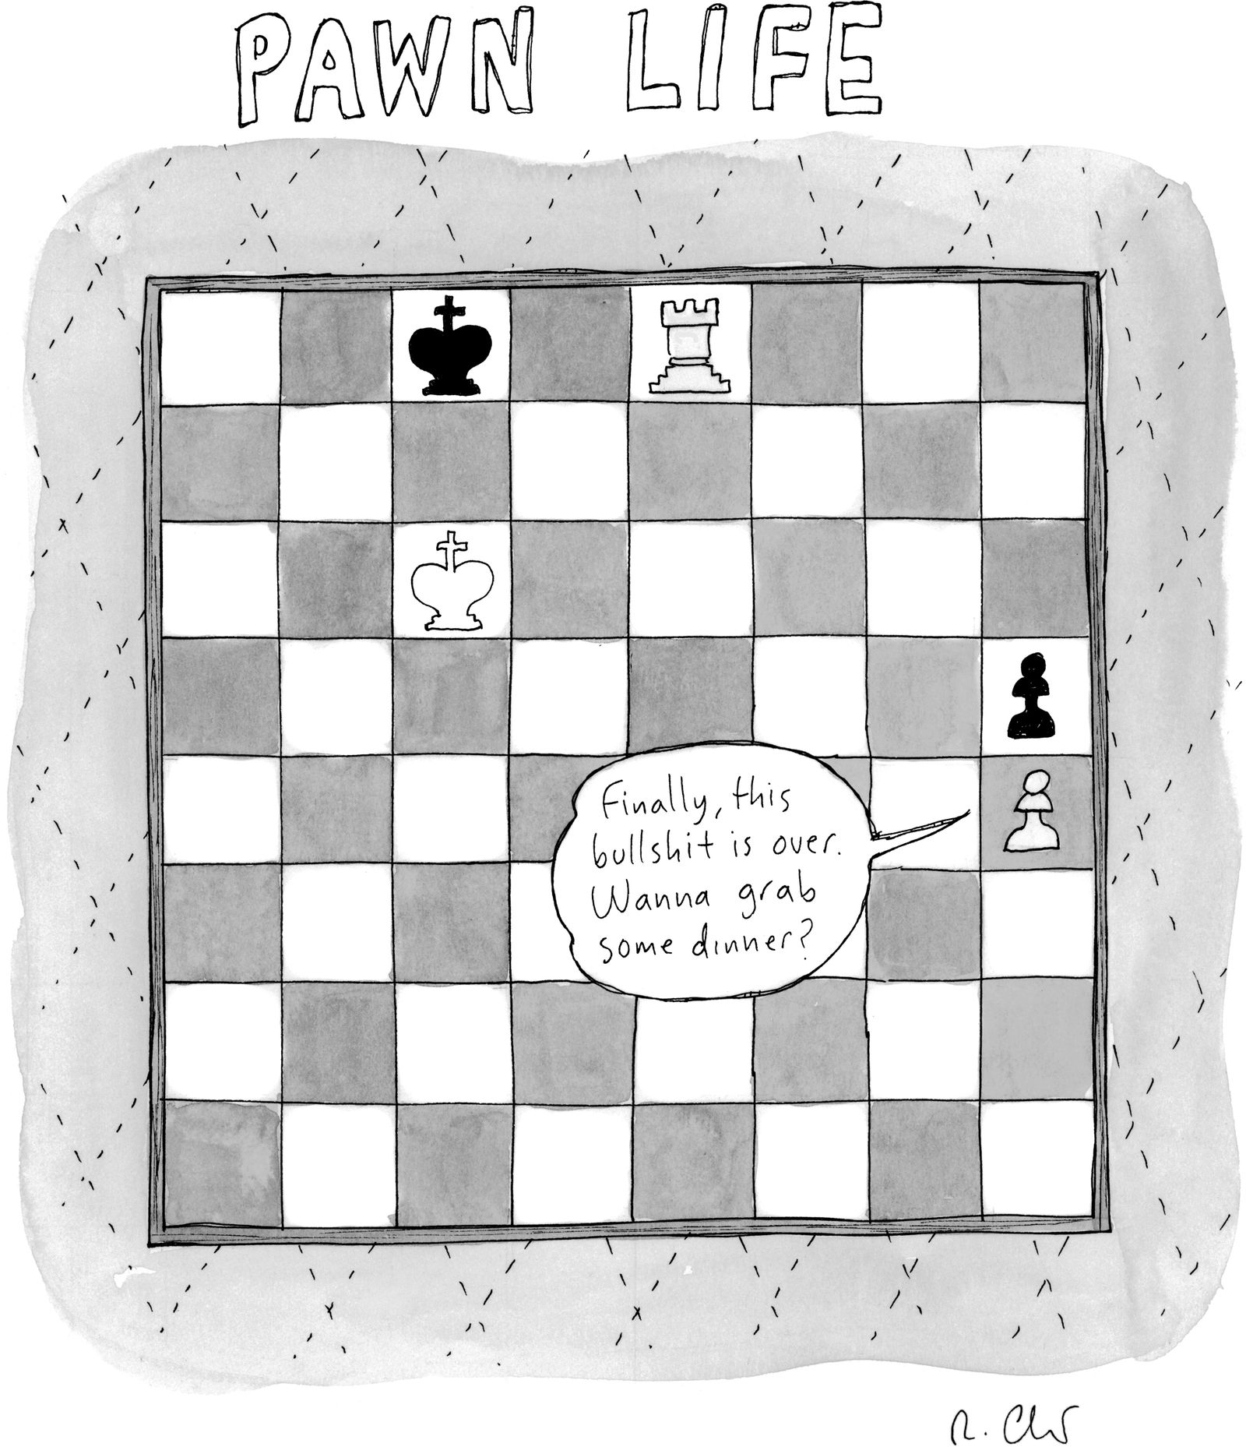](https://www.newyorker.com/cartoon/a60296)

Cartoon by Roz Chast

Copy link to cartoon

Link copied

Shop

Open cartoon gallery

Jesse told Christina he didn’t respect the doctor. Her obvious explanations, her exorbitant rates, her easy life. Maybe he should tell her about Christina’s life. Blood and shit and a million forms to fill out. In the emergency room, there was no screen between Christina and her patients. At best, there was a paper mask, plastic gloves. It was a hard life, and didn’t that make it a real life? A good life? The psychiatrist didn’t take insurance. She started every session by saying simply, How’ve you been?

The same question the woman at the coffee shop was going to ask, now that it was almost noon and the commuters were gone and so were the croissants. Jesse didn’t need to get dressed, because he’d never gotten undressed. He paused briefly in front of the bedroom door, trying to picture Christina on the other side. She always looked relaxed when she was asleep. Some mornings, he found her with her hands clasped behind her head, as if she were gazing serenely up at the clouds. The problem was that it was easier to picture her not there. A catastrophe—a car accident, a mugging, an active shooter at the hospital—or else a choice: she was tired, impatient, sad. She’d had enough. Jesse had explained to the psychiatrist that this was a special talent of his, a kind of negative imagination. Instead of conjuring things up, his fantasies preferred to make things disappear. Effortless to imagine his wife vanished, his city submerged, his art erased. Standing in front of the door, on this side of the unknown, he had the same light-headed sensation that came from thinking about anything vast: the ocean, the stars, the number of years that he would be dead.

Advertisement

He wasn’t supposed to have these thoughts. He was supposed to have a coffee, a croissant. For a moment, he pressed his forehead against the door. Then he left the apartment.

The woman behind the counter was named Bix. When he walked in, she was busy wiping down the complicated metal parts of the espresso machine. Then she turned around and her face lit up. Hers was not an especially pretty face but, like all faces, it was made beautiful by illumination. Back when he was an artist, Jesse had often said this was the reason he’d become one. Once you were a painter—well, as long as you were a painter—there was no difference between the way things seemed and the way they were. It didn’t matter whether the thing—the fruit on the counter, the coins in the tip jar, the glint in her eye—was actually as bright as it appeared to be from this particular angle, at this particular moment. Her eyes were blue just now, but one step forward, into the shadow, and they would be gray. The light didn’t trick you. It actually changed you.

I saw you in a video, Bix said, instead of her usual greeting. Her voice seemed inappropriately loud. Jesse looked quickly around the coffee shop, to check who might be listening, but it was empty except for a man in the corner, wearing enormous headphones, bent over his phone. Flakes of pastry fell onto the screen. Jesse had seen the man many times, but he didn’t know his name, or anything about him. Bix, who made a point of talking with all the regulars, even the ones who wore headphones, probably knew a lot about him. Was that her job, or just her personality? She had gone back to cleaning the spouts and knobs of the espresso machine, but she was still talking loudly. The video had been posted by one of the organizers. It showed the whole room: the banners, the dinosaurs, the museum guards caught in confusion. But there were closeups, too. She had seen him flat on his back, arms crossed, eyes closed. Half his body in shadow, the other half in light. It was really cool, she said. It was really cool to see him like that.

She kept talking—she had strong opinions about the social responsibility of artists, about role models, about finding meaning in life—but Jesse’s mind snagged on this sentence. To see him like what? To see him dead?

The officers arrived at the scene promptly, but it took a while for them to act. They milled around, watching and chatting, and every now and then one of them issued a warning through a megaphone, reminding the protesters that their behavior was unlawful, that they were required to clear the premises. This, Jesse had been told, was to be expected. Arresting two hundred people was a hassle more than anything else—a lot of paperwork. Better to wait the performance out, to hope the protesters would get restless and give up. These guys can get angry, one of the organizers had said, with the weary voice of experience, but probably not about a bunch of people taking a nap at the museum. Not about the climate. The protesters were mostly middle-aged, mostly white. They were well dressed.

Jesse had bristled at this. Wasn’t the whole point to make people angry? But once he was on the floor he was relieved. His only job was to wait for the cops to stop waiting. His heart rate slowed. His eyelids bloomed with lazy spots of color.

He knew this state of suspension well. Hours in the studio: sitting on a stool, staring at the drawer of unwilling brushes and oils, not touching a single one. Entire days on the ward: lying on the rubbery mattress, speaking to no one, staring at his hands. (The claws had disappeared in the hospital, because he couldn’t sleep in the hospital.) It was only now, a big black police boot planted next to his ear, that he understood what he had been doing with all those empty hours that had turned into empty days. He was waiting for them to stop waiting. His friends, his doctors, his wife.

How long had it been? Years had passed since that day in the car, the first time he’d tried to explain it to Christina. It wasn’t an idea. Not an emotion, either. An intuition? It came out of nowhere. No, it came from inside him. On the highway, say, if he looked too closely at the pavement rushing toward him and then rushing past him. Ignoring him. It would be so easy to put his hands in his lap, to put his feet on the floor. To let the car decide. It would be the easiest thing in the world. Stop driving, stop trying, stop playing, stop resisting.

Intuition—or was it insight? On a balcony, on the edge of the subway platform, while chopping an onion with a large, sharp knife. He simply saw what could happen. The light flashed on the blade. He did not feel despair when he saw it, or even fear. If he was being honest, he had a hard time understanding why everyone else couldn’t see it, too. Death was not the world-ending event you imagined as a child, trying to believe in your parents’ impermanence. No, he had told her, death was as ordinary as life. And did he even need to tell her? Surely she knew it better than he did. Death happened every day.

Christina had nodded, held his hand. She didn’t say the things he’d worried she might. Bland, reassuring things: that everything would be O.K., that it was all in his head. But what could she say? It *was* in his head. There was a difference between death that rolled in on a gurney, seeping through bandages, beeping on machines, and death that hovered vaguely, mutely beside you, ready to tap you on the shoulder, but not quite yet. Most people experiencing panic attacks, Christina had explained to him once, believed they were having heart attacks. They came to the hospital clutching their chests. They were disappointed by her diagnosis. Embarrassing, incurable.

She had squeezed Jesse’s hand, which meant he should squeeze back. He did it, but he barely felt it. His fingers were stiff in the cold, almost numb. While they sat there, silent and stationary, traffic rushing past them, the sun moved behind a cloud. The car got darker. Not by much—just enough for them to realize what they hadn’t noticed before: the car had been full of light. That’s what death was like, he could have said, but he didn’t.

Jesse was relieved when the door to the coffee shop jingled behind him, interrupting Bix in the middle of what she was saying about the paradox of trying to be creative in a destructive world. Jesse had said something similar himself—to Christina, to the psychiatrist—but hearing someone else say it made him embarrassed. He wasn’t failing to paint because temperatures were rising and species were disappearing and everything was made of plastic. He was failing to paint because he was showing up late to the studio and sitting on a stool and staring at his brushes. He tried to count the number of things in the studio that were made of plastic, but lost count.

The man in the doorway had broad shoulders and wore bulky gloves. I’ll take the most normal coffee you have, he said. Normal coffee with normal milk. He had to remove the gloves to get cash out of his pocket. Bix suggested a dark roast with cow’s milk. The man shrugged. Whatever you say.

While Bix poured the coffee into the cup and the milk into the coffee—the espresso machine sat clean and useless behind her—she extracted information from the man. He wasn’t from the neighborhood, wasn’t even from the city. He owned a business with his wife of thirty-five years. Bix wanted to know what kind of business, but, before he could answer, the man with the headphones appeared at the counter, holding out his empty cup and empty plate expectantly. Pastry flakes clung to the front of his sweater. As soon as Bix took the dishes from him, he retrieved his phone from his pocket and hurried out the door.

The man with the normal coffee frowned. He couldn’t believe how few people said thank you these days. Basic manners. He threw his hands in the air: *poof!* But Bix just shook her head and gave him his receipt. He has a hard life, she said.

There was a silence then, which might have been an ordinary silence or might have been a meaningful silence. Everyone waiting for someone else to speak. Jesse looked at the pastry case of crumbs to avoid looking at Bix.

Well, the man said at last. He had to say thank you, of course, but he said it uncertainly. Then Jesse was the only one left. Bix knew his order already. At some point, he couldn’t remember exactly when, she’d stopped even asking. No doubt she meant to be kind, to spare him the small humiliation of saying it out loud: the usual. Well, maybe he should have to say it. The same as yesterday. The same as tomorrow.

The machine made its unthinking sounds, whirring and grinding and gurgling, and when it was done Bix bent over the cup in silent concentration, tracing a flower on the surface. Hundreds of roses in a single day, each one identical to the last, or else she poured the whole thing out and started over.

The cops were surprisingly, ostentatiously polite when the time came—when they were done waiting. They cleared their throats awkwardly. Jesse opened his eyes and instead of the dinosaur’s bones he saw the police officer’s face, ruddy and stubbled. They had been instructed not to resist, and Jesse had always been good at following instructions. He stood up, put his hands behind his back, spoke only when spoken to. They were lined up in twos. Like boarding the ark, someone ahead of him said. Or like walking down the aisle. An officer stood behind each pair and pressed between their shoulder blades when it was time to start moving. The banners were being pulled down, but the protesters took up the slogans, chanting as they walked through the marble hallway toward the museum entrance. Some of the other museumgoers were clapping, and almost all of them had their phones out.

The children, to Jesse’s surprise, were still there, racing up and down the hall. A boy with long curly hair stopped in front of Jesse, an accusatory finger directed at his chest. That’s him, the boy said. That’s the man from the Neanderthals. A girl with identical hair pointed, too. That’s him. That’s the caveman.

They ran away, but Jesse could still hear them laughing, or thought he could. He tried to picture it: his heavy jaw, his stooped spine, his tiny skull. Hair that was more like fur. He laughed, too. Why not? He filled in the rest of the picture. Giant plants, absurd animals. Untouched stones, uncorrupted seas. The vast horizon of prehistory. The police officer told him to stop laughing and he didn’t—couldn’t. He probably sounded crazy, but he had always suspected that. Hadn’t the doctors said as much? In his mind, he painted the sky implausible purples and pinks, brighter than he’d ever seen.

When Jesse emerged from the coffee shop, the man with good manners was climbing into the cab of a truck. It idled beside the curb, a gentle growl emerging from under the hood. A few weeks ago—no, longer than that, before the hospital—Jesse had read a newspaper article about a new law in the city that fined truck drivers who left their vehicles idling for more than three minutes. At one point, he’d known exactly how many pounds of carbon dioxide an engine released per hour, but he’d forgotten. It was too hard to visualize. What did a pound of gas look like?

Anyone who filmed the idling trucks could claim a portion of the money collected through the fine. Jesse had considered joining in. Doing his part, he thought. Once or twice, he’d even taken out his phone and started recording, but he never followed through. He was too afraid of being caught. Caught trying to catch someone else. The whole thing filled him with a vague guilt he wouldn’t have been able to explain.

The man was sitting in the passenger seat of the truck. From where Jesse stood, he couldn’t see who, if anyone, was in the driver’s seat. He watched the man take the lid off his coffee cup and blow on the liquid inside. He held it carefully, almost tenderly, his fingers interlaced. Normal coffee with normal milk. Jesse took a noisy sip from his own cup, and as he swallowed he brought one hand to his throat—warmth inside and out. His pulse was faint but steady, and not for the first time he marvelled at the body’s quiet: you couldn’t hear it without touching it.

The truck idled for three minutes, then four minutes, then five. At six minutes, the man put down his coffee, rolled down the window, and said, What the hell are you staring at?

Jesse flinched, as if he’d been hit in the face. If only he’d been hit in the face, he thought. He opened his mouth and said nothing. Later, he’d be able to think of exactly the right thing to say. The thing to make the man ashamed. Better, the thing to make the man understand. But for now he could do nothing but close his mouth and stare at the blank in his brain. The man’s breath froze in the air between them. Tiny drops of coffee clung to the hair above his lip. The invisible driver pulled away from the curb, plumes of exhaust dancing in the truck’s wake.

Jesse climbed the four flights of stairs to the apartment. The drink in his hand was cold and unappealing. But so what? He could make his own coffee, or quit coffee altogether. In thirty-seven minutes, he was supposed to sit in his chair and turn on his computer and tell the psychiatrist how he’d been. But so what? He could start a new routine, or abandon routine altogether. At the top of the stairs, he tried to turn the doorknob, but it resisted. He turned it harder and it resisted more. His fingers were turning white with effort when it occurred to him that there might be someone on the other side, turning the knob in the opposite direction. He couldn’t see Christina, but he could imagine her. As soon as he let go, the door would spring open. She would look surprised, then relieved. The light would stream through the window behind her, setting her hair on fire. She would see him clearly, but for a moment—just for a moment—he would close his eyes to keep from being blinded by the sun. ♦

Published in the print edition of the [July 21, 2025](https://www.newyorker.com/magazine/2025/07/21), issue.

[*Clare Sestanovich*](https://www.newyorker.com/contributors/clare-sestanovich)*is the author of the novel “*[*Ask Me Again*](https://www.amazon.com/Ask-Me-Again-Clare-Sestanovich/dp/0593318110/)*” and the story collection “*[*Objects of Desire*](https://www.amazon.com/Objects-Desire-Stories-Clare-Sestanovich/dp/0593311191)*.” In 2022, she was named a “5 Under 35” honoree by the National Book Foundation.*